

Proteus
Change the way you play

Overview
Proteus is a 3rd person 3D action-adventure game with role-playing elements. Set in a fantasy world populated by warring tribes and hordes of monsters. The main character, Novo, has the unique ability to assume the form of creatures and use their powers. To do this, he must kill them and collect their soul essence. As the story progresses, the player will be forced to choose a side. They can either champion a tribe, help the tribes establish peace, or help destroy them all. Players’ decisions as they progress through the story will affect the outcomes. Which abilities they use and which they neglect allows each player to have a unique play style that is constantly evolving.

Project Proteus Design Team

John P Benge Game Designer | Environment Modeler

Eric Fritz Game Programmer

Andrew Patras Project Manager | Technical Director | Character Animator

Steve Tamayo Lead Character Modeler | Character Rigger | Texture Artist

Yan Zhao Lead Character Animator

Written by Andrew Patras
Version # 1.20
Friday, July 31, 2026Table of Contents

Proteus 1
Design History 4
Version 1.00 4
Version 1.10 4
Version 1.20 4
Game Overview 5
High Concept 5
Overview 5
What is the game? 5
Target Audience and Rating 5
Theme 5
Where does the game take place? 5
Example of Play 5
What do I control? 5
What is the main focus? 5
Backstory 5
Features 6
Marketing 6
What’s different? 6
Business 7
Milestone Schedule 7
GamePLAY 8
Begging Gameplay 8
Tutorial Quest 8
Controls 8
Menu System 9
Game Menu 10
Character Menu 10-11
HUD 12
Combat 12
Soul Essence 12
Healing 12
The World 13
Creatures and Forms 13
Tribal Interaction 13-14
Environments 14-15
Graphics 15
Important Terms 16
TECHNICAL________________________________________________________________________17

Poly Counts________________________________________________________________________17
Exporting for Unity_________________________________________________________________17-18
Naming Convention_____________________________________________________________18
NOVO ChARACTER SHEET_______________________________________________________19-20
ROCK GOLEM CHARACTER SHEET_______________________________________________21-22

BLADE MANTIS CHARACTER SHEET_______ __________________________________23-24

TEAM BREAKDOWN_____________________________________________________________25-26

TEAM SIGNOFF 27

Design History

Version 1.00

Version 1.00 is the expanded written concept and design. Version changes include:

- Formatted previously existing document into an official design document template format
- Incorporated new character concepts into the appropriate section
- Added information to appropriate sections

Version 1.10

Version 1.10 is a slightly changed version of the original. Version changes include:

- Fixed typing errors.

Version 1.20

Version 1.20 is an expanded design document. Version changes include:

- Included Team Performance section
- Expanded Technical section
- Incorporated images
- Incorporated creature templates

Game Overview

High Concept

Proteus is a 3D action-adventure game where the user plays as a character who can transform into creatures he has killed and use their abilities as his own.

Overview
What is the game?
Proteus is a 3rd person 3D action-adventure game with role-playing elements. Set in a fantasy world populated by warring tribes and hordes of monsters. The main character, Novo, has the unique ability to assume the form of creatures and use their powers. To do this, he must kill them and collect their soul essence. As the story progresses, the player will be forced to choose a side. They can either champion a tribe, help the tribes establish peace, of help destroy them all. Players’ decisions as they progress through the story will affect the outcomes. Which abilities they use and which they neglect allows each player to have a unique play style that is constantly evolving.

Target Audience and Rating
The target audience is mostly males ages 16 to 28 who enjoy open world games, collection games, or games that can provide many hours of enjoyment with multiple unique play-throughs. The target rating is Teen.

Theme
The game takes place in a large, open world with many vivid landscapes. Some environments include snowy mountaintops, rolling plains, barren deserts, and lush forests. The player must traverse the harsh environments to defeat monsters, steal their forms, and complete quests to advance their personal goals.

Example of Play
What do I control?
The player controls a single character, Novo, as he journeys through the game. As he gains monster forms, Novo can change his form, but the player will always control one character at a time.

What is the main focus?
War has left the three main tribes in ruins without much protection from the monsters. Though weak by nature, Novo can transform into the creatures he kills in order to overcome obstacles and achieve victory. Each player decides what their ultimate goal will be, but there are three main options to choose from. The player can help one of the three tribes achieve dominance over the others, he can help all three tribes obtain peace, or he can help the antagonist destroy all three tribes.

Backstory
Novo is one of the few surviving members of a tribe of nomads in world full of monsters. Each member of the tribe’s bloodline has the power to assume the form of creatures that inhabit the world and use their powers. There are three main tribes in the world that have been in a constant power struggle that culminated into all-out war. In the destructive aftermath, no tribe claimed complete victory and were all left in ruins. With few warriors left in each tribe, there aren’t enough people to fend off the monsters. As a result, the monster population has grown, becoming a problem for all. The hero’s tribe had maintained neutrality but was attacked by one of the other tribes in attempt to steal their food and resources. Alone in the world, the character is then forced to decide which side he should take. He must defeat monsters in order to gain their abilities to either help one of the three tribes, or to destroy all of the tribes. This backstory will be portrayed in the game as an opening cinematic, narrated as an internal monologue, before the player can start the game.

Features

- 3rd person action/adventure combat
- Destroy enemies to gain their powers
- Create your own unique play style through personal combination of available powers
- Reputation with tribes affects their reactions to you
- Utilize the quest system or set out own your own
- Player actions determine the ultimate fate of the character’s world through story branches
- High replay value

Time

Game-play Time
Predicted
Maximum: 80 hrs
Minimum: 15 hrs
Mean: 40 hrs

Product Life
The user can play through one path of the game’s main story to the end in about 15 hours. We expect the user to replay the game at least one or two other times to choose other story paths or to try different play styles. If the player has a completionist mindset and must play through each story path, there will be 5 paths to choose from, each with possible side quests. On top of the open world, there are many creature forms that can be acquired, which accommodates for different play styles and strategies. We expect the average player to play the game for 2.5 months initially, with many potential replays intermittently afterward for up to 3 years. Potential downloadable content and add-ons maybe reignite interest in the game post-release.

Marketing
Similar Products
- The Elder Scrolls IV: Oblivion
- Fable II
- Pokemon
- Kirby

Sell Points
- Multiple story paths and endings
- Many creatures and forms
- Ability to create own play style and character development
- Variety of environments

What’s different?

The main selling point and difference of this game is the ability to transform into the enemies you kill. Other games have at most one character type than can change to a few forms, such as druids, but none have built their game around it. We pull popular and enthralling concepts from other games, such as the collection aspect of Pokemon and the skill-based level up system from Oblivion and combine it with a quest-based system in a sandbox environment. Tying it all together is a multi-path story tree similar to the Fable series. Though elements are seen in other games (and arguments can be made about whether there are any original ideas anymore), no one game combines them all in this manner to make it fun.

Business

Milestone Schedule
- Week 1 - Game Pitch ( 09/29/09 )
  - Explanation of the game design to the class.

- Week 2 - Game Design Document, Character and Monster Concept (10/06/09)
  - Full description of all game features, mechanics, and elements.
  - Takes the form of a Microsoft Word document.
  - Concept sketches for character and monsters

- Week 3 – Initial Models and Animations for Main Char, 1st Monster (10/13/09)
  - Main character and 1 monster modeled, rigged, and simply textured (ST, YZ)
  - Model and Animations for main character imported into the game engine (AP)
  - Main character walk cycles keyed to movement controls (EF)
  - Initial environment model and layout (JB)

- Week 4 – Playable Demo, 1st Form Change, Basic AI (10/20/09)
  - 1 more monsters modeled, rigged, and simply textured, as form change (ST)
  - Basic animations incl. walk cycles, attack, death for monster (YZ)
  - Basic AI controlling monster movement and attacking, damage, death (EF)
  - Initial form change animation and key controls (EF)
  - More in depth environment layout and design (JB)
  - Basic HUD (AP)

-----------------
- Week 5 – Demo Revisions, 2nd Monster, Intermediate AI (10/23/09)
  - Revisions from demo
  - 1 monster modeled, rigged, and simply textured, as enemy (ST)
  - Basic animations incl. walk cycles, attack, death for prev week (YZ)
  - Intermediate AI including intelligent pathfinding, attack and move with minor (EF, AP) intelligence (i.e.: keep distance if ranged, get close if melee)
  - Better HUD (AP)
  - Quest Script (JB)

- Week 6 – 2nd Form Change, Environment, Effects (10/30/09)
  - 1 monster modeled, rigged, and simply textured, as form change (ST)
  - Basic animations incl. walk cycles, attack, death for prev week (YZ)
  - Initial Effects for projectiles and Healing Plant (JB)
  - Basic Menus, Quest Log (AP)
  - Quest Events/ Notifications (EF)

- Week 7 – 3rd Form Change
  - Better textures for first 3 models (ST)
  - Basic animations incl. walk cycles, attack, death for prev week (YZ)
  - Remaining Effects (JB)
  - Whatever else needs to be fixed or created, fine tuning of animations, HUD, controls, etc (EF, AP)

- Week 8 – Fine Tuning
  - Better textures for last 3 models
  - Fine tuning animations, everything else

- Week 9 – Open for Unforeseen Problems
- Week 10 – Presentation of Game

Gameplay
The game will follow a 3rd person action look and feel. The player will control Novo through hack-and-slash combat with different types enemies while attempting to complete different quests to help or hinder the different tribes. The player is aided by the ability to become enemy creatures once enough of them have been killed. This adds a unique strategy element to battles as the player must choose the best form for each different combat situation. However the player can only change forms a limited number of times before needed to recharge their energy, which means they must think about which form is the right one. After acquiring a form players can level-up that form to gain more powers with it by using it frequently or by killing more monsters of that type. Players will have a set number of slots to hold creature forms they can use, which can be swapped outside of combat.

Beginning Gameplay - Tutorial Quest
The player will start the game at level 1. A quest will automatically be given to the player saying that the player is hungry and that he should find some food. It will explain how to move around in the world and how to use the map to locate quest objectives. Once the player comes within a certain distance of the goal (a berry bush), the quest log will update saying that there are four low-level monsters nearby that have the same idea as you. They will not like you taking their food, so you will have to clear them out first. The tutorial will then explain to the player how to attack an enemy, as well as how to monitor their and your health meters. The first enemy will only attack you one-on-one while the others eat. After killing the first low-level monster, a second will attack you one-on-one. After this enemy is killed, the tutorial will explain the soul essence gauge and how you can assume the form of an enemy by killing enough of them and absorbing their soul essence. The final two enemies will fight you at the same time. After the introductory combat, the player will acquire the form of the creatures he just killed. The tutorial will then explain how to access the character menu, how to set forms to the skill slots, and how to change form. A single slightly stronger enemy will show up, which you must defeat. The tutorial quest log will update and explain how to change into the newly acquired form using the hotkeys. Once the player has defeated the monster and completed the tutorial, he will be given a new quest explaining that he can't keep expecting to survive on his own. He should seek out one of the three nearby tribes for food and resources. The player will then have the option of traveling to any three tribes to begin the storyline quests.

Controls
The game will be controlled with the Mouse and Keyboard.
Arrow keys or WASD: Move Character
Mouse Move: Rotate Camera
Left click: Activate Primary Ability
Right click: Activate Secondary Ability
Spacebar: Jump
E: Action, Begin Conversation
1 - 6: Hotkeys to Switch Available Form
Escape: Pause, Open Game Menu
Tab: Open Character Menu

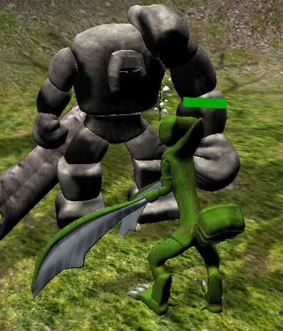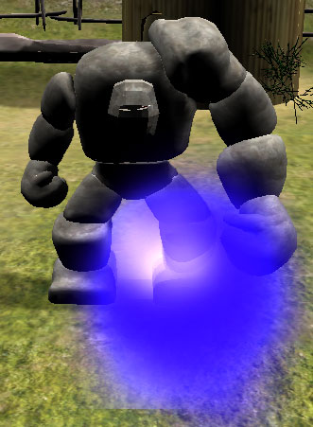

Menu System
Game Menu
- Save
- Load
- Quit
- Options
  - Video
  - Audio
  - Difficulty
Character Menu
- Character Tab
  - Image of Character
  - Base Stats
  - Health and Energy Meter
  - Inventory
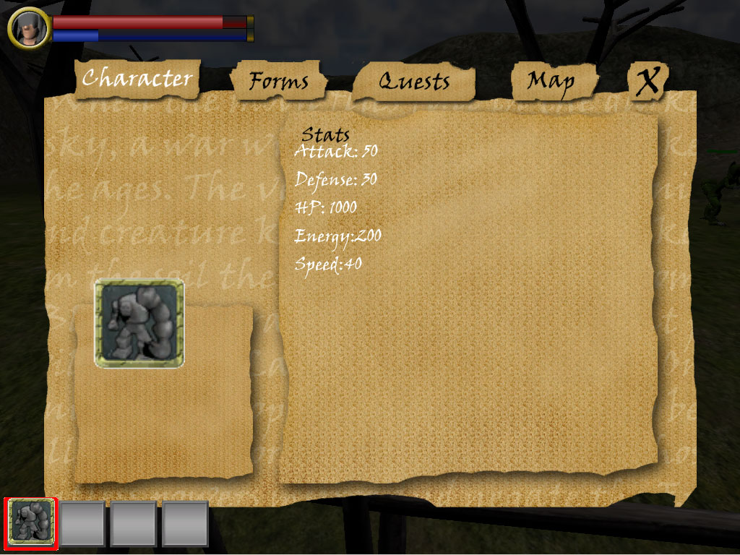

- Skill Tab
  - Current Forms w/ Recharge Times
  - List of Forms Available
  - Image of Selected Form (On Mouse Click from List)
  - Description of Selected Skill
  - Experience Gauge of Selected Form
- Quest Tab
  - Active Quests
  - Completed Quests
  - Quest Description
  - Quest Objectives
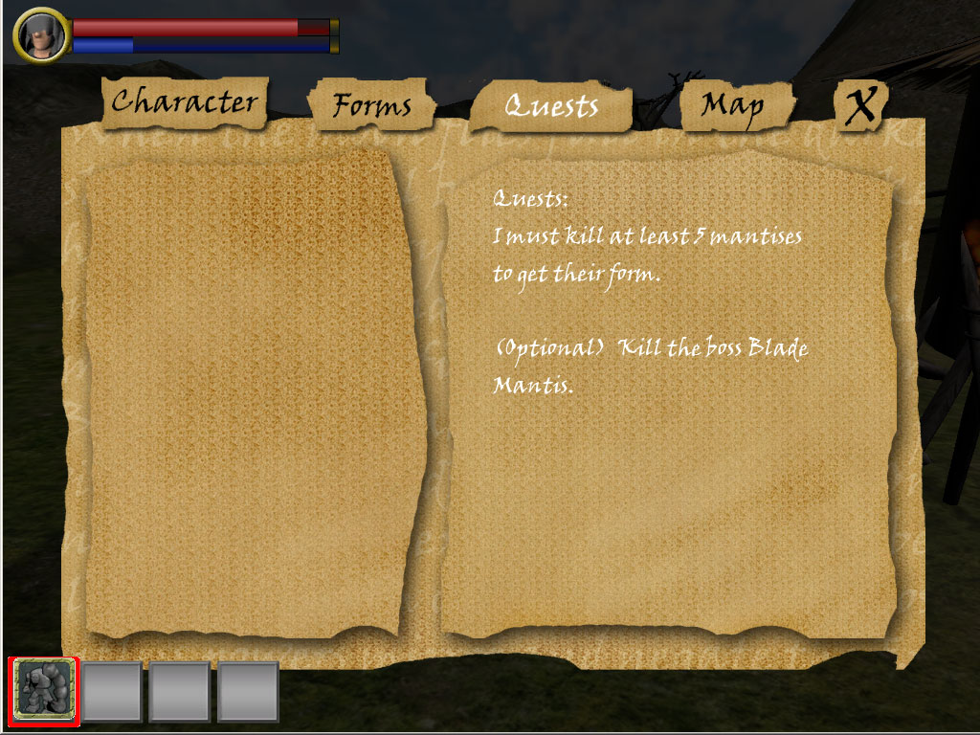
- Map Tab
  - Map
  - Markers for Quests Destinations
  - Fast Travel Options

HUD
The Skill Slots will be shown as boxes along the bottom of the screen starting from the bottom left corner. They will be boxes with a thumbnail image of the monster. Active ability slots will have the hotkey number in the top left and an 'A' in the top right. The energy bar will be on the bottom of the skill box and the name of the monster will be above the bar.
The health bar will be in the top left of the screen. It will be a red bar and the amount of health out of the max will be shown numerically in the middle of the bar. The energy bar for the active monster power will be displayed under the health bar for quick reference.
There will be a mini-map in the top right displaying the character's position as well as the immediate area, any detected enemies, NPCs, and nearby mission objectives or the direction of off-screen objectives.

Combat
Players fight enemies by transforming into different creature types that they've collected to take advantage of the current situation. The game features real-time action combat where the player can attack or block and is usually fighting multiple enemies. The player is limited to a set amount of skill slots that they can fill with their forms. These can be switched out in towns or outside of combat. Each form has an active and a passive ability that the player must choose between when placing into the skill slots. The passive skills will have a constant, albeit minor effect and don’t require the player to be in a specific form. Players are also limited by the amount of time they can stay in their Available Forms. While they are in the form, a meter will deplete until it is empty when the player will have a small window of time to switch out of the form before it starts draining their health. When they're out of that form, the meter recharges slowly. Different forms can be used in sequence to perform combo moves in combat by switching between them.
Soul Essence
When a creature is killed by the player, a hazy blue orb appears from their body and floats to the player automatically. This is the creature's soul essence and is what fills the gauge

Healing
Certain forms have a healing factor, such as plant forms. Others have a healing primary or secondary ability, such as an angel form.
There are plants throughout the world that heal the player a certain percent of their health then require a recharge time before they can be used again. They are recognizable by their white flowers and glowing wisps.
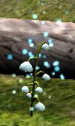
The World
Creatures and Forms
Creatures for the prototype include
Rock Golem
Defense high
Power high
Speed low
Primary smash
Secondary block
Passive higher defense
Description: A slow but powerful tank form that excels in close range combat.
Mantis
Defense low
Power medium
Speed medium
Primary slash attack
Secondary area attack to damage all enemies in front of you and push them back
Passive increase combo hit#
Description: A two-legged mantis form that uses its scythes for melee combat

TRIBAL INTERACTION
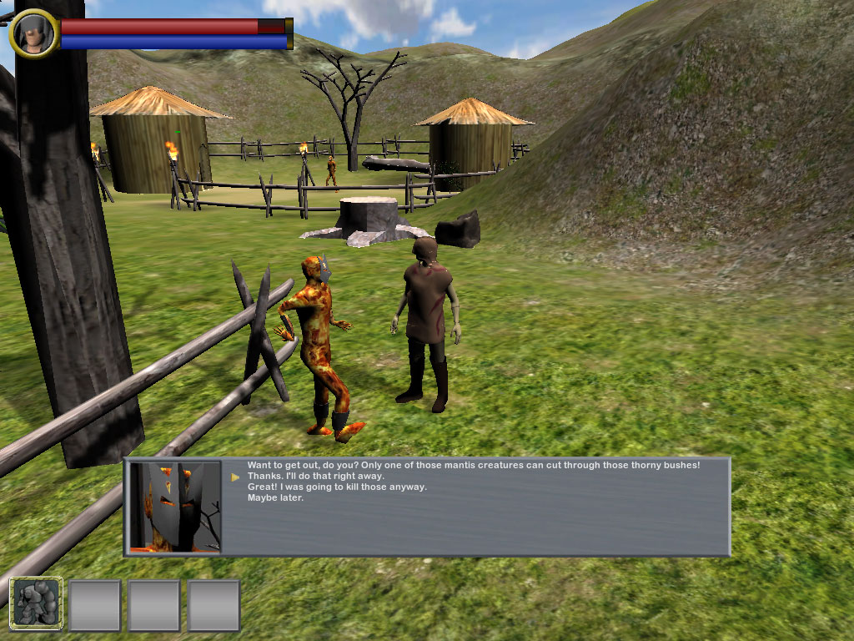
When you press the activate button next to an NPC, their dialogue opens if they have any. The camera goes to fixed facing the NPC and their statement appears. Responding dialogue options will be selectable with the mouse pointer or the Up or Down arrow keys and ENTER. Dialogue that is more than one box in length can be advanced by left mouse clicking or pressing ENTER.

If the player instead attacks the NPC, the NPC will fight back. If the player kills the NPC, he will lose favor from that tribe. The player can not, however, go below the previous threshold of favor and lose the associated ability no matter how many tribe members he kills.

As you progress through the game, you will earn favor or enmity from the tribes. Members of tribes that are aggressive towards you will attack you on sight. The benefit of helping a tribe is access to that tribe's signature abilities. These cannot be found in the wild and can't be gained by killing the tribe members. If you gain enough favor with a tribe, you will be allowed to learn one of that tribe's abilities. As you gain more favor, you will be able to learn higher level abilities. The drawback is you are locked out of gaining the signature abilities from other tribes, as well as their story arcs.

In the beginning of the game, you can freely move between the tribes and gain simple quests from all three. As you complete quests, you gain favor for the quest-giver tribe. After you reach a threshold of favor for a tribe, you will be given an "Ultimatum Quest" where you must decide whether or not you want to be that tribe's champion. You can only be champion of one tribe per play-through, but until you complete "Ultimatum Quest" you can test out all three tribes.

One of the early quests before the Ultimatum Quest no matter which tribe you choose will ask you to investigate an area that has had suspicious activity. This quest will introduce you to the antagonist who will ask you to stop helping the tribes and instead to help him destroy all three tribes. This is an optional fourth story route the player can choose which will have its own quests and unique ability rewards but will gain enmity from all tribes. Whereas allied tribe members will not attack the player, if the player allies with the creatures, the creatures will still attack the player and the player can still kill them without penalty.

Environments
For the demo we'll be making one area of the world containing a few different creature types the player can acquire. It will be at the borderlands between a dormant volcano and grassland. The volcano area would be mostly barren with lots of rocks for cover while the grassland would be mostly open ground with a few trees to break the monotony. The setting will be a level midway through the game so the player will already have several different creatures he can change into.
Other areas would include:
Forest
Snowy Tundra
Swamp
Desert
Coast
Island
Caverns

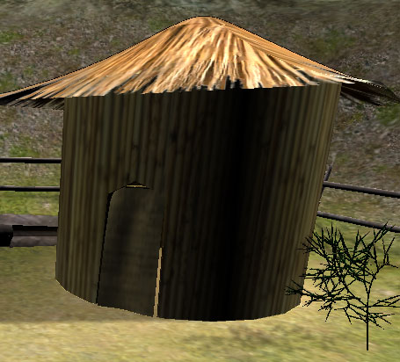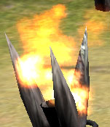
Graphics
3D graphics with mostly realistic color palettes. It won't be as realistic as Call of Duty games, but not as stylized as Fable. Natural earth tones will be used for most environments.
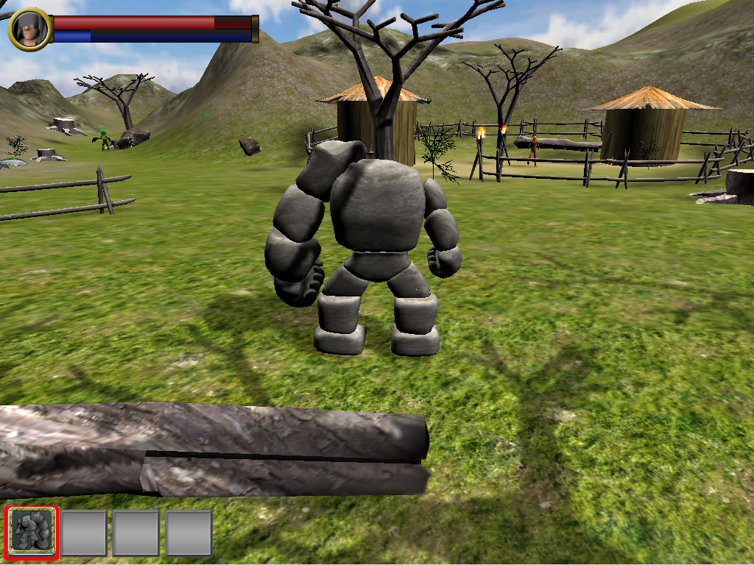

Important Terms
Novo - The main character of the game.
Creature / Monster - The general term for non-intelligent inhabitants of the world.
Form - The player's physical look and feel
Base Form - Novo's original human form. The form he defaults to when dead or out of energy
Creature Form - The visual Form of an enemy Creature or Monster
Transform - The act of changing Form between the Base Form and a Creature Form
Essence Meter - The amount of Soul Essence currently acquired from a Creature versus the amount needed to acquire that Creature Form
Soul Essence - The essence of a Creature's soul gathered upon the death of the Creature. Used as the unit of measurement for the Essence Meter.
Form Slot - One of a limited number of Creature Forms that Novo can have available at one time. Creature Forms can be swapped out of Form Slots in Allied Tribe Territories or Safe Zones.
Available Form Slot - A Form Slot that when filled with a Creature Form allows Novo to Transform in that Creature Form and use its Active Abilities.
Passive Form Slot - A Form Slot that when filled with a Creature Form activated that Creature Form's Passive Ability.
Form Gauge - The physical representation of Novo's ability to maintain a specific Creature Form. Depletes over time and with use of that Form's Creature Abilities
Energy - The unit of measurement for the Form Gauge. Every Active Creature Ability costs a certain amount of Energy to use.
Creature Ability - An attack or power only usable while in a Creature Form. Each Form has 3 Abilities. 2 Abilities are Active Abilities and 1 Ability is a Passive Ability.
Active Ability - A Creature Ability only usable when a Creature Form is placed in an Available Form Slot. Usually is an action that depletes Energy from the Form Gauge. Can only be used when Transformed into that Creature Form. Ex: A Fireball projectile attack or a Slashing melee attack.
Passive Ability - A Creature Ability only active when a Creature Form is placed in a Passive Form Slot. Usually is a constantly active boost to the player's stats or damage. Does not need to have a Creature Form active to take effect.
Tribe - A group of intelligent inhabitants of the world. There are 3 main tribes tied to the storyline.
Tribe Member - A single unit of a tribe.
Tribal Form - A unique Form gained from an Alliance with a Tribe.
Tribe Ability - Just like a Creature Ability except it must be unlocked by gaining Favor.
Reputation – Good reputation is gained for a Tribe by completing quests that aid that Tribe or by killing Tribe Members of competing Tribes. It is used to unlock Tribe Abilities. Bad reputation is gained for a Tribe by completing a major quest for a competing Tribe or by killing Tribe Members. Too much Hostility will cause Tribe Members to attack you on sight.
TECHNICAL

Poly Counts

Single Objects: < 100k polygons

Max Polygons on screen at once: ~650k polygons

Exporting For Unity

When model is complete:

>Mesh → Triangulate

>Modify → Freeze Transforms

>Edit → delete by type → non-deformer history

>Edit → keys → bake simulation

--Click on the top group in the outliner.

In the channel box, break the connections for all of this group’s keyframes (This shouldn’t affect any of the animations.)

> Window → Settings/Preferences → plug-in manager
>next to fbxmaya click “loaded”
>click close

>file → export all
>select file type “.FBX”
>name the file
>click export

--in the pop up box
>under include – geometry, check only “Smoothing Groups” and “Animation.” Leave the other boxes unchecked.

>check “Embed Media”

> leave “Convert NURBS surfaces to:” at “NURBS”

>other settings should be fine

>click “Export”

Within Unity:

>Go to Assets → Import

>find the file

>click Import

>In the Project folder in the lower right, click on the object

>change the scale factor from 0.1 to 1.

>click-drag the imported asset into the scene

Naming Convention
Animations:
characterName_cycleDescription_versionNumber
ex: fireElemental_walkCycle_1
ex: rockGolem_runCycle_1

Characters and Creatures should have:

idle
walk
run
jump
crouch
primaryAttack
secondaryAttack
hit
death

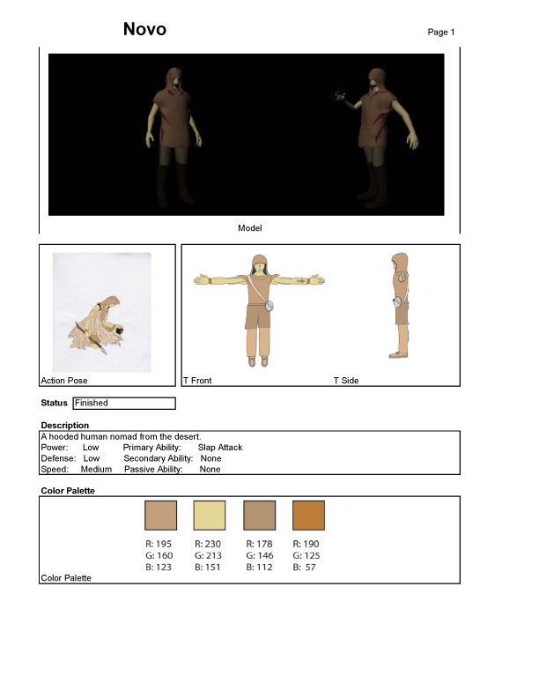

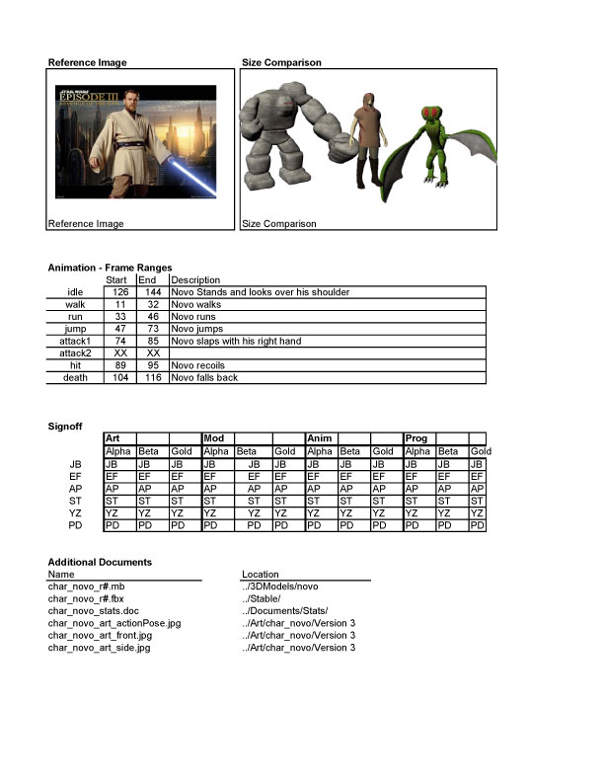

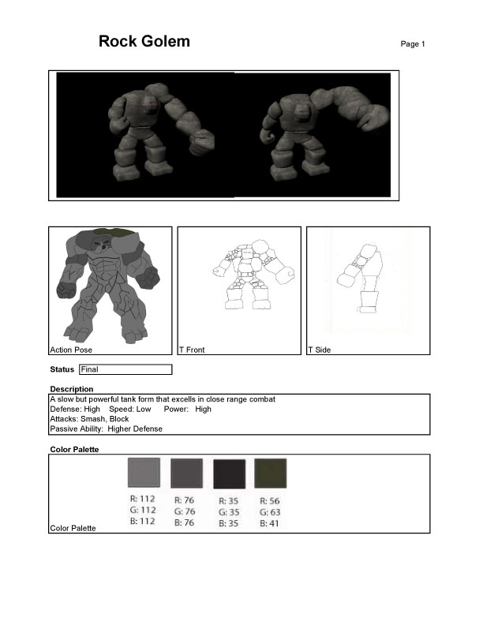

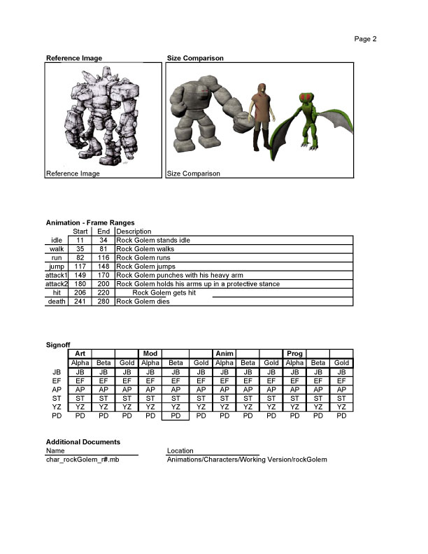

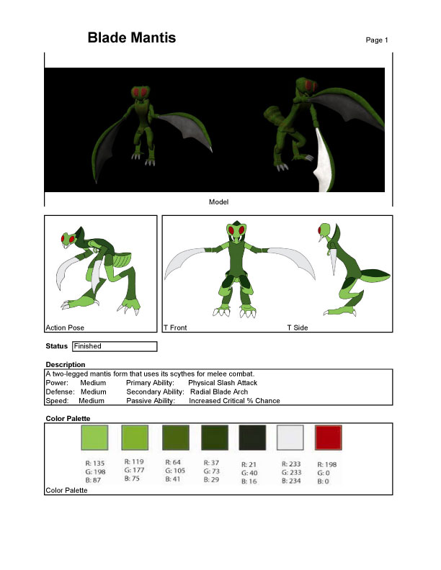

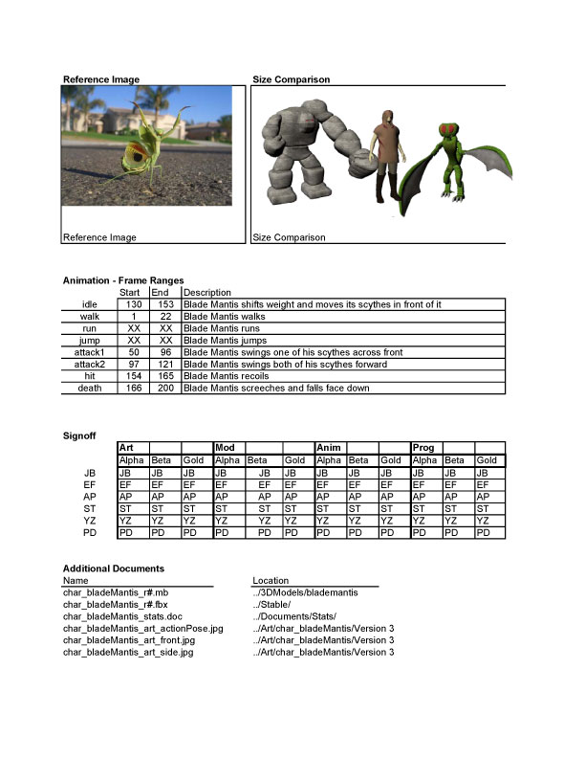

Team Performance

JP Benge
Terrain sculpting and painting
Lighting
Mantis UV layout
Torch model
Torch texture
Torch particles
Fence model
Fence texture
Hut model
Hut texture
Healing plant model
Healing plant texture
Healing alpha particles
Scroll model
Some sound implementation
Story Development
Select presentation slides
General trouble-shooting
Alpha Menu Art
Final Rock Golem UVs
Final Rock Golem Texture
Character Sheets
Select Presentation Slides

Eric Fritz
All Programming
- Including: Enemy AI, Object Actions, Game Controls, Quests System, Menu System
Asset Management
Select Presentation Slides

Andrew Patras
Team Management
Alpha HUD
Final Health and Stamina
Beta Character Art – Mantis
Beta Character Art – Novo
Final Character Art – Mantis
Final Character Art – Rock Golem
Final Menu Art
Alpha Mantis Animations
Game Design Doc v1.00
Game Design Doc v1.10
Game Design Doc v1.20
Final NPC Dialogue
Scroll Dialogue
Crystal Model
Rock Model
Rock Texture
Wall Collider Placement
Object Collision Boxes
Tree Modeling and Generation
Tree Texturing
Final Environment Object Placement
Character Sheets
Select Week Presentation and Scrum Slides

Steve Tamayo
Story Development
Block Boy Alpha Model
Block Boy Alpha Rig
Block Boy Alpha Animation
Alpha Character Art – Mantis
Alpha Character Art – Rock Golem
Alpha Character Art – Novo
Final Character Art – Novo
Mantis Models
Mantis Textures
Mantis Alpha Rig
Rock Golem Alpha Rig
Rock Golem Alpha Model
Novo Alpha Rig
Novo Models
Novo Textures
Scroll Texture
Sound Acquisition and Adjustment
HUD Character Panel
Character Sheets
Select Presentation Slides

Yan Zhao
Fire Elemental Final Model
Fire Elemental Final Texture
Fire Elemental Final Animations
Alpha Character Art – Rock Golem
Beta Character Art – Rock Golem
Rock Golem Final Model
Rock Golem Alpha Textures
Rock Golem Rig and Animations
Mantis Final Animations
Novo Rig and Animations
Select Presentation Slides

Team Signoff

__John Benge________________________________________
John P Benge

__Eric Fritz__________________________________________
Eric Fritz

_Andrew Patras________________________________________
Andrew Patras

__Steve Tamayo______________________________________
Steve Tamayo

___Yan Zhao_________________________________________
Yan Zhao

