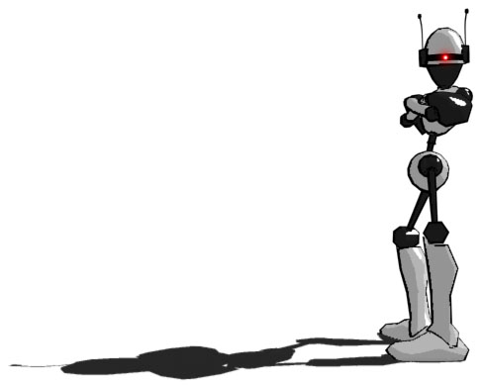
Bright White Entertainment

Design Document for:

Project: Bolt

“Blur your senses.”

Written by Seth Kendall, Pat Kemp, Juan Cardarelli, and Phil Doran

Tuesday, December 6, 2004

All work Copyright © 2004 by Drexel University

Table of Contents
Introduction | 5
Idea | 5
Overview | 5
Theme | 5
Back Story | 5
Feature Set | 6
General Features | 6
Game Play Features | 6
Marketing | 7
Similar Products | 7
Rez | 7
Amplitude | 8
Viewtiful Joe | 9
Sell Point | 10
Target Audience & Rating | 10
Target Platforms | 10
Business | 11
Milestone Schedule | 11
Production Team | 12
Game Characters | 12
Player Character: Blip | 12
Enemies | 13
Game World | 14
Levels | 14
Sectors | 14
Scale | 15
Travel | 15
Hidden Locations | 15
Time | 16
Game World Appearance | 16
Game Camera | 16
Special Move Camera | 16
Cut-scene Camera | 16
Music | 17
Character Interaction | 18
Movement | 18
Upgrades | 20
Special Moves/Weapons | 22
User Interface | 23
Layout | 23
Color Meter | 24
Point Score | 24
Jumps Remaining | 24
Special Move Indicator | 25
Character Specifics | 25
Blip | 25
BallBot | 26
ClawBot | 26
RocketBot | 27
FlyBot | 27
MuscleBot | 27
Game World Specifics | 28
Sector 5 | 29
Sector 4 | 30
Sector 3 | 31
Sector 2 | 32
Sector 1 | 33
Boss Levels | 34
Game Flow/Navigation Chart | 37
Game Engine | 38
World Editor | 38
Model Editor | 38
Script Editor | 39
C-Script | 39
Appendix A: Log of Work | 40
Appendix B: Journal of Technical Problems | 43

Introduction

Idea
Project: Bolt is a three-dimensional, music-based action game where the player runs down hallways smashing up waves of enemy robots to the beat of the music.

Overview
Our hero Blip must navigate the many levels of the futuristic, underground city substructure to reach the surface while fighting past the thousands of robots that are trying to stop him. As Blip runs down each hallway level, he must strike enemy robots with the beat of the music in order to get the most experience points as well as raising his Color-Meter.
The Color-Meter is indicative of how well the player is doing, and it determines how much color and visual effects are in the game. Each level starts in bland grayscale, and more and more saturation is added as the color-meter is raised. Once the Color-Meter reaches Full-Color, Blip is able to perform his super moves and combos to better combat the enemies.

Theme
Set in a futuristic, stylized setting of an underground city substructure populated entirely by robots, Project: Bolt will have a very modern theme that will be emphasized by the electronica soundtrack.
The dreariness of the robots’ everyday lives will be the thematic impulse that Blip is fighting against. Blip’s struggle to reach the surface of the city and ultimately to feel alive is illustrated by the raising of the Color-Meter in each level and bringing the screen to life.

Back Story
The plot of Project: Bolt takes place in the future where cities are built upon layer and layer of subterranean substructures where all the manual labor is performed by robots. The opening cut scene introduces our hero, Blip, as a middle-management robot directing garbage operations in the lowest tier of the underground levels. His entire life consists of giving orders to less-intelligent worker robots. One day, Blip notices a discarded photograph of a lush wilderness landscape which sparks something in him. Tucking the photograph away, Blip looks at a cross-section schematic of the entire city substructure and his section at the bottom of the diagram marked “You Are Here”. Then, determined to see the surface for himself, Blip sets off on his adventure to make his way through the endless corridors and elevators to reach the surface. The only problem is that every robot in the facility stands between him and the sunlight. The game then consists of Blip destroying wave after wave of worker robots that are trying to stop him as well as defeating bosses, which are other higher-intelligence, management robots.
The end of the game will be a cut scene of Blip finally reaching the surface, escaping the city, and finding himself in a natural environment somewhat similar to the landscape in his photograph. At that point, Blip falls to his knees and begins clawing at his head casing. Then the cut scene enters Blip’s mind as he flashes back to his distant memories of running through the fields playing as a human child. Then, as the jarring flashbacks continue, we discover that as a child Blip was diagnosed with a fatal, incurable disease that wreaked havoc on the children of that time. We then see scenes of Blip going into some sort of brain surgery, and then we are thrust back into the present with robot Blip actually ripping the top of his head off, revealing a human brain wired within his head casing. Finally, having realized the meaning of his existence, Blip hesitates while he considers what to do next, and then begins running in the field, playing and credits roll.

Feature Set

General Features
- Addictive music-based game play
- Vivid 3D levels that the player brings to life through playing
- Customizable super moves and combos that the player acquires with experience points
- Ability to replay levels to perfect high scores and achieve special challenges
- Immersive electronica soundtrack to supply the beat to destroy enemies to as well as draw the player into the experience
- Countless hidden “Easter Eggs”
- 100 level campaign

Game Play Features
- Completely novel experience
- Excellent varied techno tracks
- Unique graphical style based on cel shading
- Eye catching special effects
- Never-before-done color system causing the game to become more lush and vibrant based on player’s success. Color meter also doubles as “life bar.”
- “Experience Point” system carries monetary value
- Visually stunning & incredibly effective special moves
- Certain special moves will activate slow motion cinematic sequences
- Varied upgrades to character can be “purchased” between levels: extra speed/attack range
- Loads of mini-goals while in full color mode (i.e. “Hit 6 blue robots in the next 20 seconds for 100 points!!”)
- Special BOSS battles every 10 levels
- Bosses carry weapons/equipment that may be equipped after victory
- Varied level locations within subterranean world as well as an above ground city
- Ability to save replays of levels for posting or later viewing
- Hidden levels with huge exp. point bonuses and secret weapons/upgrades/special moves

Marketing

Similar Products

Rez
Released: January 15, 2002 for Playstation 2
Genre: Action, Shooter
ESRB: E for Everyone
Ratings: IGN 8.5
IGN Readers 8.8
GameSpot 7.9
GameSpot Readers 9.0
(All scores are out of 10)
As far as game play is concerned, Rez is the most similar game to Project: Bolt. Rez was a sleeper hit that has gained a huge cult following. It targeted all age ranges, mostly fans of techno style music. The main character will shoot beams from his hands in correlation to where the player places his cursor. The game follows a wire frame character as he flies through a colorful world shooting different enemies. The music and colors would evolve with your game play, giving the user a psychedelic experience. The game would take you through various different levels, which looked similar to music visualization plug-in. The gaming experience is long the same lines as Project: Bolt, although the game play would be very different.
Rez has received rave reviews because of its original style, and unique feel. However, its lack of advertising hurt its sales. Although the game has its cult following, it became a sleeper hit. The main problem is that the game is a little to experimental for most people. Visually, Project: Bolt is much less abstract; this will guarantee that the average gamer will not be overwhelmed. Project: Bolt takes what Rez tried to do, and adds a much deeper and more engaging game play element. The most important difference is that Project: Bolt isn’t a gimmick, there’s an incredible game to back up the visual style.

Amplitude
Released: March 24, 2003 for Playstation 2
Genre: Action, Music
ESRB: T for Teen
Ratings: IGN 9.3
IGN Readers 9.2
GameSpot 8.8
GameSpot Readers 8.7
(All scores are out of 10)
To sum up Amplitude “if there were a game that could bring mainstream appeal to the niche genre of rhythm games, this would be it.”-Ryan Davis (gamespot.com). This is the reaction that Project Bolt is trying to earn. Amplitude has been called by many reviewers as an addicting “trippy” game. All of the internet publications all agreed that the game really made the music genre fun. Project Bolt is building on what Amplitude built, by reinventing the game play into a more action based experience.
Amplitude’s structure is very similar to Project Bolt. The player plays through the level and is allowed to upgrade his player at the end of the specific level. However, the player upgrades the vehicle rather than the actual biped character. As the player advances through the musical colored challenges he gains these points to spend. The main idea is there although the implementation is simpler.
While this game was not a huge money maker, it definitely impressed the gaming community and gained and cult crowd. Project Bolt will take advantage of this new genre of gamin but will apply it to a larger fan base for larger distribution of the game.

Viewtiful Joe
Released: October 7, 2003
Genre: Fighting/Action
ESRB: T for Teen
Ratings: IGN 9.5
IGN Readers 9.2
GameSpot 9.2
GameSpot Readers 9.0
(All scores are out of 10)
Viewtiful Joe is a 2D/3D side-scroller with a revolutionary and simply gorgeous visual style. Although the game play is 2 dimensional, all models are 3D cell shaded and stunningly animated with bold and bright visual effects livening all actions from jumps to attacks. Project: Bolt is going to very similar visually. The game play of Viewtiful Joe is much like your traditional 2D side-scroller action game; however, the 3d environments, stunningly original visual style, and time-twisting special effects transformed it into a new and exciting experience. Project: Bolt will take that same process to the next level, creating an exciting experience not only visually but auditory and tactile. Combat attacks work in much the same way as well, whereas there is one generic attack button driving complex and interesting hand-to-hand attacks.

Sell Point
Project: Bolt’s big competitive advantage is its original combination of arcade style music-based beat games and visually exciting smash ‘em up action games into a new experience that will blur the senses. The main focus is the novel, yet simple, interactive style of smashing up enemies to the beats of the music and enjoying the visual richness that ensues as a result of the player’s success. The simplicity of level design allows the user to fully immerse themselves in the music and visuals instead of having to think about where to go. Games that have dared to explore the music/action realm have had good reviews but poor mainstream sales. Project Bolt
The simple, yet engaging arcade-style game play allows for almost infinite replay value, which will appeal to both the young teen arcade game junkies and to older adult gamers who just have 10-20 minutes to kill.

Target Audience & Rating
Project: Bolt is a fast-paced arcade game with scintillating visual and auditory elements designed to keep the player caught up in the game, level after level. The game will be enjoyable to all ages with simple enough game play for younger audiences to learn coupled with challenging enough levels of difficulty to keep more mature audiences interested.
Project: Bolt will be a general audience title with non-graphic, robot violence. There will be no offensive or objectionable material and should receive an ESRB rating of E’.

Target Platforms
Because Project: Bolt would best be played with a simple, controller-based interface, its ideal platform would be console or arcade, but it could also be played on a PC or Macintosh.

Business

Milestone Schedule
- Game Pitch (10/04/04)
  - Intended to be an explanation of the game design to the class.
  - Takes the form of a Microsoft PowerPoint presentation.
- Game Design Document (11/18/04)
  - Full description of all game features, mechanics, and elements.
  - Takes the form of a Microsoft Word document.
- Technical Design Document (12/06/04)
  - Explanation of the technical design of the game.
  - Takes the form of a Microsoft Word document.
- First Engine Proof (03/01/05)
  - Features a working three-dimensional graphics engine, complete with textured and animated character models.
  - Allows for player control over main character.
  - Computer driven opponents in place.
- Revised Game and Technical Design Documents (02/05/05)
- First Playable (03/10/05)
  - The player can complete one level and gain experience.
  - The player can purchase end of level upgrades.
  - Playable on target machine.
  - Color meter is working with simple, but temporary effects
- Pre-alpha (03/14/05)
  - The player will be able to use special moves.
  - Multiple levels will be in place.
  - Title screen and all game menus in place.
- Alpha (003/27/05)
  - All visual elements will be in place.
  - Player may save progress between levels.
  - First ten levels operational with one boss sequence.
- Focus Groups (04/07/05)
- Beta (04/19/05)
- Gold (05/03/05)
  - Feature complete and bug-free.
  - Intro and end of game cut-scenes created.

Production Team
Seth Kendall - Lead Modeler and Animator. In charge of all 3D models and
animations.
Patrick Kemp - Lead Programmer and Level Artist. In charge of creating the working
engine, all programming, and level designs.
Juan Cardarelli - Lead Audio Engineer and Effects Director. In charge of all music
tracks, sound effects, and visual special effects.
Philip Doran - Lead Designer. Cheif creator of concept art, in charge of all creative
direction in order to maintain a consistent visual syle.

Game Characters
The hero of the game is Blip, a robot who becomes fed up with his dreary life and decides to try to escape the massive city substructure. Aside from Blip, all the other characters are enemies that come in the form of other robots who have been ordered to stop Blip’s getaway. See the Character Specifics section for more detailed explanations of Blip and his enemies.

Player Character: Blip
When the game begins, Blip is the same for all players. As the game progresses and as the player collects experience points and defeats bosses, special moves and even weapons become available to the player. Earning and selecting these upgrades are where players are able to customize Blip to their liking. By the end up the 100 levels, there are many combinations of special moves and weapons that define the character’s abilities.

Enemies
Enemies come in the form of worker robots and security robots that have been diverted from their normal activity to stop Blip’s escape from the facility. There are many different varieties that the robots come in, each with their own type of conveyance and form of attack. The robots are divided into three main types: low, medium, and high attack ranges.
The types of robots that will come at Blip change depending on what sector they are in. For example, in Sector 5: Waste Disposal, the enemy robots will mostly be obsolete worker robots, whereas in Sector 3: Manufacturing, the robots will be more up to date and modern looking because that sector is more profitable and requires better equipment. Along the same lines the two sectors inhabited by humans, Sector 2: Sub-City and Sector 1: Surface City, will have security, police, and even military robots attacking Blip in order to protect the population from his rampage.

Game World
Through the 100 levels, Blip journeys from miles beneath the surface of the earth within a deep network of machine civilizations all the way up to the surface city and finally out to the freedom of the natural world.
The player will never navigate manually through the world, but their progression from the depths of the underground city to the surface will be reflected by the change in scenery. The 100 game play levels will be separated into 5 sectors of 20 levels each. Each sector will have a distinctive visual style reflecting the purpose of that sector in the substructure. See the Game World Specifics section for more detailed explanations of the levels and sectors.

Levels
The levels of Project: Bolt will be numerous and varied. There will be 100 levels in which our hero, Blip, travels on foot from the deepest bowels of the subterranean machine waste disposal facilities up through various types of factories, through an open underground city, and up through the surface city.
The player does not control where to explore in the levels; he is on a predetermined path. Since the focus of the game is really on the unique and challenging beat-combat system, the levels will merely act as visual elements to keep the game interesting; and we do intend to keep it interesting. Blip will be running through hallways, over catwalks, up and down the sides of buildings, in streets, through warehouses, and much more.

Sectors
The game starts in Sector 5: Waste Disposal, the deepest sector. Sector 5 is populated entirely by robots and is responsible for handling all the waste materials produced by the entire city. The environment will be very run-down, rusted, and bleak.
The next sector is Sector 4: Mining & Refinery, where, as the name suggests, raw materials are mined from the earth and refined into usable materials by a robot workforce. The environment in Sector 4 will be more modern and maintained than Sector 5, although the rust and decay will be replaced with industrial grime.
Sector 3: Manufacturing is the next sector up, where the raw materials from Sector 4 are used to produce everything the city needs, including vehicles, equipment, and robots. Sector 3 is dominated by factories and assembly lines, and all the facilities are modern and up to date.
Next, Sector 2: Sub-City is the area directly below the surface of the earth where a subterranean city has been built below the main city. This is the first sector that is actually inhabited by human beings, although no humans will be encountered by the player because there have been security alerts and evacuations in the player’s vicinity. It is essentially a normal city, except that there is a massive steel framework ceiling over it and many of the taller buildings extend right into the ceiling and out to the surface. The environment consists of subsidized housing, seedy business places, and grungy streets because the Sub-City is essentially the bad part of town.
Finally, Sector 1: Surface is the main city and is on the surface. Sector 1 is a booming metropolis with skyscrapers and monorails. This is where all of the respectable businesses and elite citizens reside. Once again, the player will not encounter any humans because they have already been alerted to the player’s presence and have evacuated. The environment is very clean and modern.

Scale
The overall scale of the environment will be very large due to the sheer quantity of levels. However, each level will vary in scale from one to another. They will all have a fairly equal length along the player’s path; however the area around the path will vary from tight, cramped hallways to large warehouses to enormous, open cities. There will be a drastic level of detail reduction in far-from-camera geometry in the larger city levels so as to still convey the enormous space without slowing down game play. For a game that is so precisely time-based like this, computer lag is out of the question and must be eliminated with careful optimization of levels.

Travel
The player’s entire journey will be on foot through waves of enemies. Within each level, the player moves automatically forward toward the next zone. However, in between levels movement to the next level will be implied by a still behind the level start menu and then a short, 5-10 second cut scene preceding the next level.

Hidden Locations
There will be five hidden locations throughout the game where the experience points gained from kills will be much higher from ordinary levels. The scenery for these levels will be full of hilariously out of place ads, scenery, and references to other video games. The only way to unlock these levels would be to knock a certain type of enemy through a specific section of wall. There will be clues preceding the target area if one is paying close attention to the surroundings. However, due to the nature of the game play, these will be rarely found. This adds to the game’s allure, as their existence will become rumored legend causing increased replay value. Secret weapons and upgrades will be available in these levels as well. Secret locations are one of many “Easter Eggs” scattered throughout the game.

Time
Since the majority of the game is underground, large scale time will not be an issue. In fact, any suggestion of the passage of time would hurt the game play, since it is intended to be one long adrenaline rush on the part of the hero robot. Since the character moves at a constant speed through each level, it will take the same amount of time to complete them, regardless of the player’s success.

Game World Appearance
The game world will have a very stylized, animated look, similar in appearance to comic books or anime. The level elements themselves will be cell shaded, similar to the look of Zelda: Windwalker for Nintendo Gamecube, while the characters and particle effects will be a blend of that cell shaded style and the comic book style of Viewtiful Joe. There will be some degree of motion blur building up as the color meter rises to increase the adrenaline flow and really bring all of the player’s focus toward the oncoming enemies.

Game Camera
The camera is placed above and behind the main character so that we can clearly see him kick ass, as well as clearly see all oncoming enemies and a good deal of the surroundings. There are two situations where the camera changes.

Special Move Camera
While in full color mode, certain special moves (i.e. special moves that wipe out all visible enemies) will cause the camera to change to a cinematic point of view such as slowly rotating from one side of the character to the other while the move is acted out in a slow motion non-interactive sequence. The music will slow down and be toned back as well while extra sound effects are added on top. Immediately following the move, the camera cuts back to normal and music/game play return to normal. Only certain moves lend themselves to this effect, because the player needs time to recover after the flow is interrupted.

Cut-scene Camera
During the pre-level cut-scenes, the camera will change to best show the entrance into the new level.
Music
There will be a plethora of electronic music. The music will range from slow to fast tempo depending on the level, but each level will have a constant tempo. The player will be challenged to hit the enemy on beat to make the color meter rise; otherwise the enemy will be destroyed but the color meter will not increase.
The first sector will use music that is very fast tempo and simple to imply the urgency of the escape. The second sector will have a much slower and quieter feel to imply a spookiness of sorts through the mines. When you reach the manufacturing sector a more disturbing type of music will be played. The fourth sectors music will get a little more complex then the rest and a little faster than but not as fast as the first sector, it will be a build up of anticipation for the break to the surface. To show this the tempo will get faster and faster up until the boss fight. The last sector, the surface, will be very fast tempo, very exciting, and very complex.

Character Interaction
As a reward for the player’s success, various upgrades, special moves, and even weapons will be available throughout the game. Upgrades and special moves will be “purchased” for experience points in the pre-level menus. This encourages a player to do their best, and go back to replay levels that could have been done better. Secret upgrades and special moves will become available only after a player has completed a hidden level. Upgrades will be slight modifications to the character that affect either speed or attack range (Attack range translates to more “give” if a player is slightly of beat or unaligned).
Movements
In the beginning your movement options will be limited to a few simple moves: run, side run, and jump. As you progress through the game your movement will be improved through the purchase of upgrades.

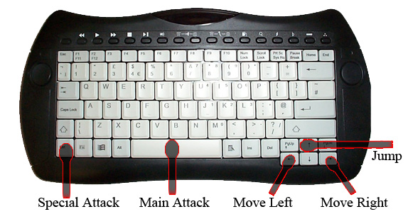

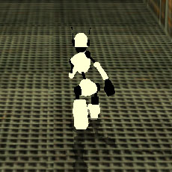 | Blip is in a mad dash for the surface, and there is no time to stop and smell the roses. Run blip through 100 levels all the way to his goal.
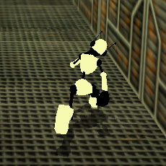 | Of course the path is full of enemies, so Blip must maneuver. When the player moves left or right, Blip will strafe in the direction that was pressed.
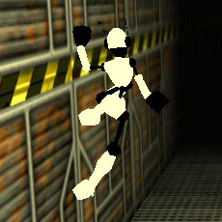 | To avoid part damage, instead of slamming into side walls, Blip gracefully slides down.
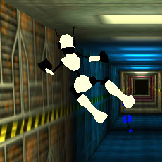 | With the right upgrades, Blip can spring himself off of walls in a move called Wall Jumping. If performed right, he can just back and forth between walls without touching the ground. This can be very useful for hitting high flying enemies or getting across missing floor. There is a limit to the number of consecutive wall jumps which can be increased through upgrades.
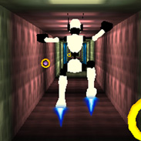 | The rocket jump upgrade allows Blip to jump higher and come down in a controlled float. The better the upgrade, the longer he can float.

Upgrades
Upgrades can be “purchased” between levels with points. These upgrades will permanently effect things like attack speed/range and maneuverability for the rest of the game. By the end of the game, the player will be faster and more forgiving in attacks than at the beginning due to his upgrades. These upgrades will generally come in different levels such as in the case of the wall jump. The first level will only allow you to wall jump once in a while the second level upgrade will allow the player to jump off of 3 consecutive walls and so on. The wall drag upgrade will allow the player to make a slower, more controlled slide down the wall. The initial rocket feet upgrade will allow the player to jump higher and come down in a float; eventually you will be able to purchase an extended flight upgrade which will allow the player to stay in the air for a certain amount of seconds depending on the level of the upgrade.
On top of the movement upgrades you will be able to also purchase armor with experience points. The armor will allow your color meter to become more resistant to enemy hits. At the end of every level the player will be able to purchase upgrades with the points they received during the current mission as well as those that were not used from previous levels. On top of that, the different armors will be weak or strong against certain enemies, so that the player could switch depending on what sector and level he was playing in. You can also upgrade your boots and gloves in order to improve their weapon ability. Theses upgrades would center more on increasing your points as opposed to increasing your color meter.
Icon | Upgrade Name | Upgrade Description
 | Rocket Boosters | Lets you jump higher and come down slowly after jumping.  (Multiple) Upgrade: +1 second of air time
 | Wall Jump | Lets you jump off the wall  ( Multiple ) Upgrade: +1 more wall jump in a row
 | Smart Chip | Increases the color received for perfect kills  (Equipped) Upgrade: + 10% color
 | Super AI Chip | Increases the color received for perfect kills  (Equipped) Upgrade: + 25% color
 | Emotion Chip | Increases the color received for perfect kills  (Equipped) Upgrade: + 50% color
 | Circuit Armor | Lowers the amount of color lost when struck  (Equipped) Upgrade: - 10% color
 | Nuclear Armor | Lowers the amount of color lost when struck  (Equipped) Upgrade: - 25% color
 | Fusion Armor | Lowers the amount of color lost when struck  (Equipped) Upgrade: - 50% color
 | Spike Fists | Increases points received for perfect kills  (Equipped) Upgrade: +10% points
 | Thunder Knuckles | Increases points received for perfect kills  (Equipped) Upgrade: +50% points
 | Diamond Claws | Increases points received for perfect kills  (Equipped) Upgrade: +25% points

Special Moves/Weapons
Special Weapons and Special Moves effectively work the same way. The player can equip a special weapon that will open up a new special move while equipped. Weapons can be “purchased” in the same way as upgrades. A player will keep an “arsenal” of special moves from which he can have any one equipped during a level. These special moves will be highly visual as well as very powerful. They will range from long ranged attacks to massive hit combos that will blow all the enemies off the screen in one move. The player will have the option of using a special moves button that will only be active once the player has reached full color. On top of this, there will be a cool down time for the move. For example: a move may only be used once in full color mode and only once every minute. The special move will be set and purchased at the end of the level like the weapons and upgrade. You will only be able to set one special move per level so the player will have to be wise about his choice.

Icon | Special Weapon Name | Special Weapon Attack
 | Plasma Boomerang | Blip throws the weapon down the hall as it kills all nearby air-bots.
 | Sonic Hammer | Blip slams the ground and sends a shockwave down the hallway killing every bot in its path.
 | Shock Stick | Blip slams the stick on the ground electrocuting any ground-bots directly perpendicular to him.
 | Beam Sword | Blip takes out sword and begins to spin in slow motion hitting everyone he comes into contact with.

User Interface

Layout
The main in-game user interface will consist of the full screen game-screen with certain UI elements layered on top. These elements include the Color Meter, the Point score, Jumps Remaining and the Special Move indicator. Consequentially these may also be referred to as the Chromometer, Scorometer, Springometer, and Juice.
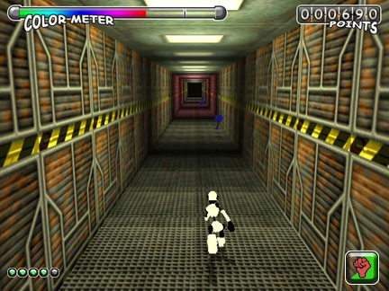

Color Meter
The Color Meter is placed in the top left of the screen with the words “COLOR METER” clearly labeling it. This bar accurately reflects the “color level” based on how well and frequently the player is bashing up baddies. The Color Meter will start out about 10 percent full, in full grayscale. The higher it gets, the more colorful and animated it will become. In full color mode, it will be flashing and bouncing around wildly with “FULL COLOR MODE” flashing. While a player can generally tell how he is doing based on the overall screen saturation, if the ever wants to know what his exactly situation is, the Color Meter is the place to look.
Note: Since player will die when color runs out, the Color Meter essentially acts as a life bar would in other games.

Point Score
The Point Score will take its place in the top right of the screen, and will be clearly labeled “POINTS”. It will look similar to a cartoonized version of a car odometer, with the player’s total game score displayed within. As points are added, the score will animate the way an odometer would change, scrolling the numbers to be changed. When animated the motion of individual slots will look somewhat like the motion of icons in a slot machine. If a special move is done, the score will animate in a particular way, emphasizing the extra points added. Same goes for combos like hitting 20 baddies in a row without missing. In those cases, it will give positive feedback both audibly and visually, like “WHAT A STREAK!” and “YOU’RE ON A ROLL!”

Jumps Remaining
In the bottom left corner of the screen are several little bubbles, usually all lit. These is the Jumps Remaining. One very useful move a player can do is jump off of walls, rocketing himself to the other side of the hallway. When timed properly, a player can jump back and forth between walls without touching the ground. However there is a limit to how many times, even if properly executed, a player can continue wall jumping back and forth in a row. This becomes very important in later levels. The total number of bubbles in the bottom left of the screen reflects the number of times the player can wall jump consecutively. This number can be increased by purchasing upgrades. As a player jumps between walls, his bubbles will turn off, indicating how many he has left before he must touch the ground. This UI element is be very simple, able to read out of the corner of one’s eye, and unobtrusive.

Special Move indicator
The Special Move indicator is located at the bottom right of the screen. Its purpose it to tell the player when he may use his selected special move again as well as show the charge progress. A little icon representing the selected special move would slowly reveal itself in a radial wipe fashion. Once the icon is fully visible, the special move is charged and ready to be used. The icon will flash accordingly to let the player know it is ready.

Character Specifics

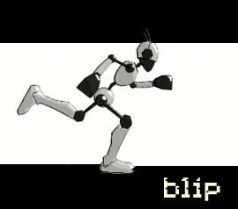
Blip
Blip is the hero of the game. He is intelligent, quick on his feet, and fueled by music and the desire for escape. His sturdy frame and high-powered servo motors allow for amazing feats of martial arts and acrobatics. His head mounted antennae pipe in the thumping techno tracks that keep him going.

Enemies

Enemies in this game are numerous and varied. They are a mass of machines, native to specific sectors and levels, who have taken up the cause to stop your rampage. Enemies make up the chief gameplay element in Project Bolt. In order to do well and advance, the player must destroy a certain number of enemies. Enemies are also the sole source of points, which are used to buy upgrades for the player. Here is a list of enemies with a few already created for demo purposes.

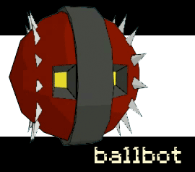

BallBot
Ballbot is a rolling robot that has a very fast attack speed. Ballbot is a low attack range robot, so Blip would have to stay low to the ground to attack him. Since this robot is very fast, it would add another element of difficulty to successfully destroying him.

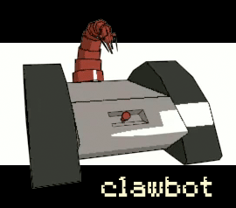

Clawbot
Clawbot is one of the prevalent robots in the Mining and Refinery zone. Much like Ballbot, Clawbot is a low attack range robot. While not as fast as Ballbot, this enemy deals more damage.

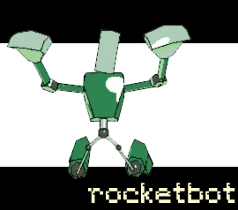
Rocketbot
The manufacturing level is full of hard working bipeds. Rocketbot is a biped that has rocket packs on his feet. This makes Rocketbot a lethal enemy, because he can attack with all four appendices. On top of it all, Rocketbot is a high attack range robot. This means that Blip must be up in the air in order to hit him. Rocketbot’s main attack is his huge fists; he can pack quite a punch with his swinging arms

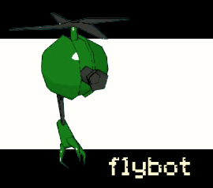
Flybot
The sub city is a security intensive area. Flybot is one of the many security style robots that are guarding the entrance to the surface city. Flybot has a huge claw that is suspended below his helicopter blades. The claw attacks at the main character, and this makes Flybot a high attack range enemy. His defense is low, although he has a moderate attack power.

Musclebot
The surface city has the most remarkable and exciting robots of all; Musclebot is one of the stronger enemies. The actual robot is a biped that walks at a steady pace. He is a medium attack range robot. His attacks are primarily melee, by using his huge arms and legs to hit with tremendous power.

Game World Specifics
Each individual level in Project: Bolt will essentially be a winding hallway, although for visual interest the “hallway” can actually be any sort of environment that constricts the characters movement to a certain path. Some variants can be running along a heavy wall separating sections of the underground city, the top of a moving subway train, or a catwalk hanging over a factory. Most of the levels, however, will be literal hallways, although elements such as the view out the passing windows or the architecture of the corridor will keep the levels from being monotonous.
Levels within a sector will be paired off into similar settings, so levels 1 and 2 of a sector might be in a hallway of some kind and levels 3 and 4 might be on a bridge. No level elements, including moving surfaces or inclines, will affect the game play. They will be purely for visual interest and to break up the hallway style of level design.

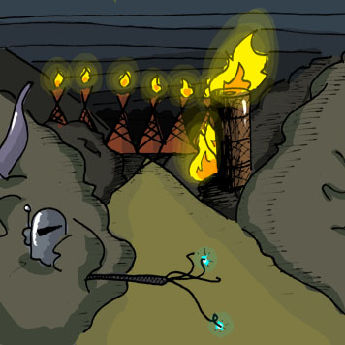
Sector 5
The first sector played is Sector 5: waste management facility. This is where Blip used to work, and it is the farthest facility from the surface. The overall look is very dark, dingy, and disgusting. Most of the robots in this level will be very obviously waste disposal robots, such as broom robots, trash compactor robots, miniature dump truck robots, vacuum robots, that kind of thing. After twenty levels, the player will move the next sector.

Sector 5: Waste Disposal - Level Designs
Level 1 & 2 | Path through a junkyard. Crushed cars and piles of machinery and trash form walls on either side.
Levels 3 & 4 | Moving trash conveyor belt confined by steel walls on either side. The player will be running against the motion of the belt.
Levels 5 & 6 | Twisting and turning trash chute. The player will be slightly uphill, but the slope will not affect game play.
Levels 7, 8 | Steel corridor lined with submarine-like doors and portholes.
Levels 9 & 10 (Boss Stage) | Steel-grate catwalk suspended by wires over a junkyard. The catwalk will sway slightly, which will not affect game play.
Levels 11 & 12 | Hallway with windows on the left through which a junkyard can be seen and on the right there are terminals to operate machinery.
Levels 13 & 14 | Path between lines of large cylindrical waste storage tanks.
Levels 15 &16 | Maintenance corridor with discarded equipment and debris lying against the walls.
Levels 17 & 18 | Passage between massive trash compactors and incinerators.
Levels 19 & 20 (Sector Boss) | Bridge over incinerators. Rising smoke and chutes dumping trash into the incinerators can be seen on either side of the bridge.

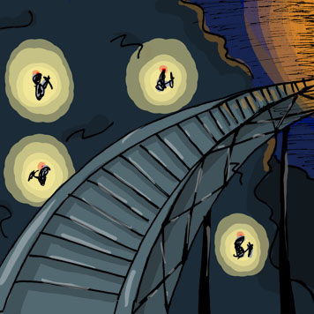
Sector 4
The second sector played is Sector 4: Mining and Refinery. These levels will have a lot to do with rock and mineral refining. There will be levels where the player moves through dusty mines, over catwalks in processing centers where we see rock purification, all that good stuff, and so on. This sector will generally have a dark, dusty look. Just as in the previous sector, the robot designs will reflect the location.
Sector 4: Mining & Refinery - Level Designs
Level 1 & 2 | Mineshaft with hewn rock walls and tracks for mine cars on the ground.
Levels 3 & 4 | Mine car track bridge that is supported over a dark chasm. Mining robots can be seen working on cliff faces in the distance to either side of the bridge
Levels 5 & 6 | Equipment storage facility. A painted pathway is lined on either side by deactivated mining vehicles and various mining mechanisms.
Levels 7, 8 | Mineral conveyor belt moving opposite the player’s running. Machines on either side can be seen sorting and checking small mineral samples.
Levels 9 & 10 (Boss Stage) | Suspended sky bridge overhanging a chasm. Glass walls on either side show large excavation machines mining the walls.
Levels 11 & 12 | Windowless service corridor lined with large steel doors.
Levels 13 & 14 | Floor of a steel refinery where a railed-off pathway is flanked by huge industrial machines.
Levels 15 &16 | Moving freight train carrying ore through a tunnel. Player is moving opposite the train’s motion
Levels 17 & 18 | Command corridor with outwardly slanting windows on either side overlooking the refinery.
Levels 19 & 20 (Sector Boss) | Catwalk over a steel refinery hanging over vats of molten steel.

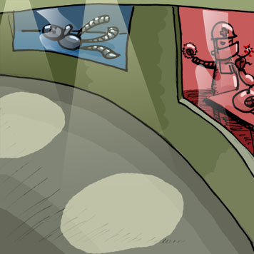
Sector 3
The third sector played will be Sector 2: Manufacturing. This is an interesting sector because we get to fight on conveyor belts with all sorts of cranes and machines everywhere, see robots being built, and so on. The look of these levels will be brighter, more energetic, and overall just more.

Sector 3: Manufacturing - Level Designs
Level 1 & 2 | Corridor under construction. Portions of walls will be missing with exposed steel reinforcements and alternate pathways will be cordoned off by construction barriers
Levels 3 & 4 | Factory floor where large scale machinery is being produced. Off to the side of the railed-off pathway, small robots can be seen welding large pieces of equipment.
Levels 5 & 6 | Glass-bottomed catwalk over a factory floor. Factory activity can be seen below and to either side of the catwalk.
Levels 7, 8 | Storage area with completed industrial machinery stacked ceiling-high on shelves which form a pathway.
Levels 9 & 10 (Boss Stage) | Moving conveyor belt assembly line. The player is running with the motion of the belt.
Levels 11 & 12 | Factory floor on top of the assembly line machinery. The player will run across consecutive box-like machines performing tasks on the assembly line below.
Levels 13 & 14 | Robot storage facility with glass-front, standing containers that enclose various completed robots on either side of a railed-off pathway
Levels 15 &16 | Corridor through the R&D section of a robot factory. Windows on either side of the hallway show rooms where experimental robots are being designed and developed.
Levels 17 & 18 | Observation hallway to a robot testing area. Floor-to-ceiling window on the right wall show various stages of robot testing, and monitors on the left wall show data.
Levels 19 & 20 (Sector Boss) | Security Corridor with cautions signs alerting the end of the robot-only industrial sectors and proximity to populated sectors.

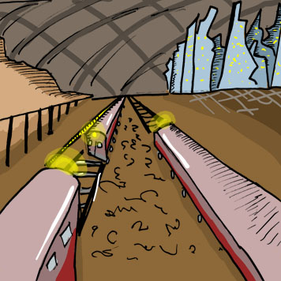
Sector 2
The fourth sector is the subterranean city. Here is where the scenery really gets cool. We finally have “outdoor” levels in city streets, up and down the sides of buildings, on trains and so on. These levels may be expansive, but they are still deep beneath the surface.

Sector 2: Sub-City - Level Designs
Level 1 & 2 | Sewer system with very shallow water flowing on the floor. Water is dripping from the ceiling and occasional pipes protrude from the walls, pouring sewage.
Levels 3 & 4 | Subway shaft with a track on the floor and graffiti covered steel walls to either side.
Levels 5 & 6 | Open city street. At intersections, barricades block off other streets, keeping the player on a single path.
Levels 7, 8 | Train station where the player is running between unmoving trains.
Levels 9 & 10 (Boss Stage) | Elevated train track about 3 stories above street level that winds between buildings.
Levels 11 & 12 | Office building hallway, lined by vacant offices. Windows on the left side show the Sub-City skyline.
Levels 13 & 14 | Slum-like, residential street lined on both sides by cars and, behind them, subsidized housing buildings.
Levels 15 &16 | Strip mall commercial district with flashy neon signs and security blockades.
Levels 17 & 18 | On top of a huge, concrete inter-city wall with razor wire on either side of the path and occasional security towers along the wall.
Levels 19 & 20 (Sector Boss) | Empty monorail tunnel which is well-kept and lined with bill boards advertising Surface City attractions.

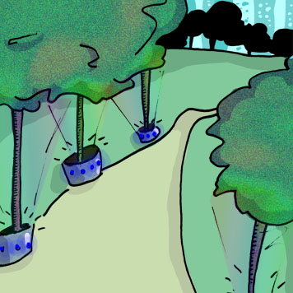
Sector 1
The fifth and final sector is the surface city. These levels are truly beautiful. Everything is bright, sunny, energetic, chaotic, and extremely difficult. We will be doing many of the same things as the last sector; however everything here is just extreme. Cars everywhere, lots of activity, extremely intense. We want the player to really take on a sort of mad dash for the end of the game at this point. This is why everything gets bright, happy and outdoors for the first time.
Sector 1: Surface City - Level Designs
Level 1 & 2 | Customs facility corridor with screening equipment and security posts along the walls.
Levels 3 & 4 | City street cordoned off by security barricades.
Levels 5 & 6 | Along trail in an artificial city park with holographic projections of trees and bushes, lined with benches.
Levels 7, 8 | Elevated walkway with rails on either side, going up and over a massive freeway
Levels 9 & 10 (Boss Stage) | On top of a speeding monorail train weaving between skyscrapers. The player is running with the train’s motion and the speed is blurring the background.
Levels 11 & 12 | City street in the residential district. Trendy houses and apartments line either side of the street.
Levels 13 & 14 | Alongside a waterway on a railed pathway. To the left is a concrete wall and to the right are a rail and then the waterway. Bridges pass over the player occasionally.
Levels 15 &16 | Security corridor lined with huge steel doors and barricades.
Levels 17 & 18 | Along the massive outer-city wall’s perimeter. Watch towers and security posts are placed all over the wall.
Levels 19 & 20 (Sector Boss) | Down the drastically sloping wall of the massive outer-city wall between pylons towards open land outside of the city.

Boss Levels
There are two kinds of boss levels throughout the game. Sector boss levels will be the last level of every sector. Therefore, every 20 levels, the player will face off with a sector boss. Halfway through each sector, the player encounters a sub-sector boss.
Boss levels add a unique twist to the game play experience. Each boss level will involve a slightly different game play experience. While different, they still adhere to the rules of game play that exist within the entire game. Boss levels give us the chance to experiment with different game play elements not included in the standard levels and give the player a welcome breath of fresh air from the somewhat repetitive game play goals of the standard levels. Whatever the bosses introduce in the form of combat or scripted events, will carry over into normal levels. (For example: Ball n’ Chain boss destroys the ground under Blip so he has to wall jump. This would become a part for the normal levels after this boss fight.)

Level 10 – Color Shifter
Color Shifter is the first boss the player encounters. The robot positions himself in front of Blip matching his speed. The boss generates 6 smaller enemy robots, each one of a different color. These bots fly towards blip, and he must choose one to attack successfully. One of the 6 robots will share the color of the main boss. This is the robot that Blip must attack. The main boss robot will then switch colors, and releases a new batch of enemies for Blip to attack. After 10 successful attack, Blip will have defeated this boss.

Level 20 – Force Field Fiend
Force Field Fiend is a boss in which you must avoid a large force field. The boss runs ahead of you shooting back a force field that takes up the entire hallway. The field however has one small space for Blip to jump or wall slide through. After Blip successfully avoids 3 of these giant force field planes, the boss will slow down; this is Blip’s chance to hit him. He will need to hit the boss 3 different times in order to destroy him.

Level 30 – Pulse Gunner
Pulse Gunner is a flying robot has a gigantic pulse cannon attached to its bottom side. This helicopter-bot swings in front of Blip and begins charging his canon. The charging takes 3 seconds, and then energy blast is released. Blip must avoid this rather large energy blast. After he shoots it, the pulse gunner flies towards blip, this is where he must attack him. After the gunner passes Blip, he flies around the level in order to set up his cannon once again in front of Blip.

Level 40 – Ball n’ Chain
Ball n’ Chain is a flying robot which swings a gigantic black flail. The boss flies around the open level, while Blip runs his path. When the boss fires his flail, the ground caves in under it and ahead of Blip. With no ground, Blip must wall jump from side to side in order to stay alive. This would be easier with a higher upgrade in wall jump, although achievable with a lesser upgraded jump. The boss would occasionally fly by blip so that he could attack him.

Level 50 – Mad Bomber
Mad Bomber is a large, rolling robot who rolls along in front of you. A compartment opens up and launches back bouncing bombs. Since these balls bounce around, they can be difficult to avoid and even more difficult to hit. When these bombs get back to you, they automatically explode, damaging you regardless of proximity. The only way to counter his bombs are to intercept and knock back his own bots into him.

Level 60 – Hyper Drive
Hyper Drive is the sector boss for Sector 3: Manufacturing. He is a biped robot with incredible strength and durability. He runs much like Blip does, although he is not restricted by gravity, he can run down walls. The boss can also run through the walls as he chases/runs to blip. This battle is very back and forth, as the player is not sure what wall, ceiling, or floor Hyper Drive is going to bust through next. Blip will get chances to attack him as he runs through the level.

Level 70 – The Grappler
The grappler is a spider-like robot. His specialty is launching his hook-shot grappling hook at you. His hook is either open or closed in a fist. When in a fist, the player may strike it back at The Grappler. When opened, the player must avoid it. After it passes, he can swing it around from long range for you to dodge.

Level 80 – Rocketeer
The Rocketeer is the sector boss for Sector 2: Sub-City. He is a large, flying attack chopper. In addition to other attacks, he fires a special cloaking missile. This missile cloaks just before reaching the player. The player must compensate and punch the missiles back at the Rocketeer in order to destroy him.

Level 90 - Protector
The Protector is in charge of all security measures for the surface sector. He is a flying biped who uses a combination of force field attacks, missile attacks, and melee attacks.

Level 100 - My Little Friend
My Little Friend is the final boss of the game and the final battle. He is anything but little…

Game Flow/Navigation Chart
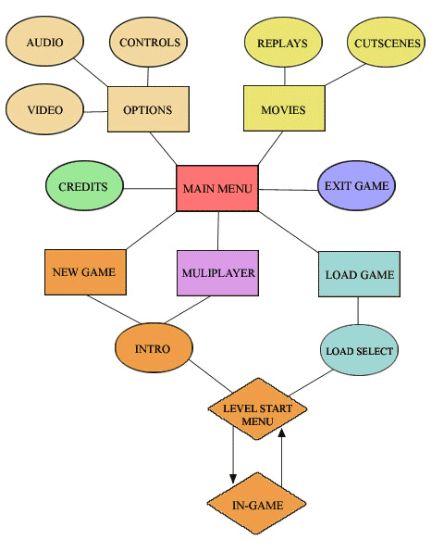

Game Engine
The game engine used for Project: Bolt is 3D Game Studio. 3D Game Studio is known as being an affordable, user-friendly game engine capable of professional level results. Notable features include a complete level editing utility, a modeling utility, and a script editor. The scripting language used by 3D Game Studio is C-Script, a “C” based language. The game comes with robust template scripts that provide a springboard for projects, especially 1st-person shooters. 3D Game Studio also boasts a very good support community that is available via tutorial collections and user forums.

World Editor (WED)
3D Game Studio’s built in level editor, WED, provides basic level editing tools as well as a level compiler for testing purposes. The user interface could be more intuitive, but after some familiarization and adjustment it suffices. The tools for laying and manipulating textures are easy to use, making custom level development a fairly painless task. WED uses block-based level construction, so it is a change from modeling in 3D Studio Max. Most of the custom level structures are made by very limited vertex manipulation and a solid Boolean subtract function called CSG Subtract. Simple application features like multiple selections and “undo/redo” leave much to be desired in WED. All in all, WED has proven to be a quirky but adequate tool that is the best choice for making levels for use with 3D Game Studio.

Model Editor (MED)
The Model Editor that comes with 3D Game Studio provides for basic modeling of low-poly game characters as well as texturing and animating tools. For use with Project: Bolt, MED’s primary function was that of a go-between for converting MilkShape 3D files to usable 3D Game Studio formats. All of the actual modeling was done in 3D Studio Max. Because of conversion difficulties, MilkShape 3D was selected because it is free and has a wide variety of formats it can export to. Models directly imported from MilkShape 3D, however, had problems, so the final model work flow went from 3D Studio Max to MilkShape 3D to MED to the game engine. MED’s texturing capabilities are limited, but since most of Project: Blip’s models have simple flat colors the tools are sufficient. This solution may prove to be temporary if more advanced shaders become an option. As far as animation is concerned, MED has not been included in the workflow, but that might have to change in order to utilized 3D Game Studio’s bones animation support. For the time being, frame-based animation is sufficient, so MilkShape’s animation tools are preferred.

Script Editor (SED)
SED is a solid script editor with plenty of useful features to make programming as painless as it can be. The ability to jump to variables or functions in your code via a sidebar cuts down on wasted time sifting through text. Organizational features like group tabbing of code and minimizing sections of code enclosed by curly brackets help make the code a lot more legible.

C-Script
C-Script is the scripting language used by 3D Game Studio. Based on the “C” programming language, C-Script is very simple as far as programming languages go. Experience with JavaScript or C++ is more than enough to qualify someone for using C-Script. A notable feature of the language is the heavy use of the dot (“.”) operator for referencing variables and functions belonging to an entity. This allows for very simple interaction between entities which translates into easy player-environment interaction.

3D Game Studio comes with comprehensive template scripts that have evolved since the earliest incarnations of the engine. These template scripts can help for referencing scripting techniques, provide portions of code to accomplish certain tasks, or even serve as a foundation for “programming-free” game creation. The “click-together” capabilities of 3D Game Studio are limited, of course, and are only totally fleshed out for the 1st person shooter genre. Project: Bolt uses no template scripts at all, opting for a from-scratch approach which as so far wielded positive results.

Appendix A: Log of Work
Week 11
- Juan: finish the demo level + 2d sprite creation.
- Seth: finish the remaining animations for blip and enemies.
- Pat: code in the sprite animations and introduce combat. Implement HUD.
- Phil: finish menu system and all other 2D in game art.

Week 9-10

- Got the first Demo running and playable.
- Seth animated the run cycle. Pat implemented run cycle to game. Familiarized with the MED and textured in it.
- Pat scripted random array of enemies.
- Phil drew out concept sketches for the demo level.
- Seth optimized Blip’s mesh to 2200 polygons.
- Juan made beginning of level for demo, although it wasn’t working by class.
Ran into problems with importing “.mdl” files. (ex. Have to animate from Milkshape 3D instead of motionbuilder/3d max)
- Ran into problem with importing geometry from 3DS Max. Level made in Max has to be scrapped. Juan has to make level in the WED from now on.
- Realized jump physics needed to be worked on, and controls reversed. Left/Right acceleration needed to be increased. Wall jumping a necessity.
- Juan finished building and texturing one of the demo levels.
- Seth nearly completed his demo level, along with textures.
- Pat introduced the working HUD into the demo, also added enemy robots.
- Wall jump animations were added and controls were made easier.

Week 8

- Seth made punch and punch combo animations.
- Juan designed the beginning of the previous demo level in 3d Max. Rendered out test screens.
- Phil made some rough level sketches for what may or may not be the demo level. Including an overhead view.
- Pat mastered Game Studio’s WED and SED (researched and learning C-Script)
- Juan and Seth familiarized with the WED. (read through tutorials, and made test levels).
Week 7

- Dropped Ogre
- Phil drew a few more concept robots.
- Seth finished the jump animation in Motionbuilder.
- Juan modeled a new enemy and programmed particle sparks emitting from his weapon. Even though the sparks would only be used to show it in the presentation.
- Pat and Juan looking for an Ogre replacement because of the lack of scripting language.
- Came to conclusion that boss battle would not be possible in the demo.

Week 6

- Pat modeled and animated 2 of the concept art enemies in low poly.
- Juan modeled and animated 2 more of the concept art enemies in low poly.
- Juan made a composite image of Blip and the HUD in a level. Added the visuals for Normal mode, Full color mode, and the almost dead mode.
- Phil and Seth worked out the first boss battle that we wanted to have in the final demo.
- Pat and Juan filled out more sections of GDD for midterm submission.

Week 5

- Selected Ogre as our game engine. Ogre has particle effects, and cell shading which we need.
- Seth researched/contacted game engine producers and picked out Ogre.
- Pat designed the Heads Up Display, and made an animated GIF to show how it would upgrade.
- Pat drew and designed the city sector map, which laid out the trek that Blip would travel.
- Seth modeled main character Blip in 3600 polygons, rigged for animation, created a few action poses, and animated initial run cycle.
- Phil drew 5 drawings that expressed each of the 5 sectors in the game.
- Pat scanned and shaded in Phil’s drawings for our presentation.
- Juan was really sick.

Week 4

- Pat and Seth worked over AIM at night fleshing out majority of GDD. This included the structure of the level system.
- Team chose the final look for Blip.
- Juan created a website to serve as a headquarters for the project. Added section dealing with Design Document, Visuals, Concept Art, and About us. He then translated the GDD into HTML format, as well as arranged the concept art section with the new artwork.
- Pat scanned and shaded all of the drawings, making them ready for our presentation.
- Seth created several 3D mockup tests to determine optimal camera angle.
- Argued about the name of the game to no avail, will keep Project Bolt for now.

Week 3

- Expanded the 1 pager in the executive summery, Seth and Pat wrote it.
- Used the 1 pager as model for the summery.
- Phil began making concept drawings for main character, aka Blip.

Week 2

- Juan came up with the original idea of a game. A beat’em up robot game that was linked to music, as well as color.
- Threw ideas around until most of the actual game was ready for the 1 pager proposal.
- Juan wrote the 1 pager.

Appendix B: Journal of Technical Problems

At the start of this project, Bright White Entertainment tried to avoid as many technical problems by making Project Bolt a simple yet enthralling game. From the artistic perspective, the team knew at all times what the look and the feel of the game would end up being. The only real problem was working with a suitable engine.

The technical work began in 3D Studio Max, as Seth, Pat, and Juan began to model all of the characters that would make an appearance in the demo of the game. The main character, Blip, was modeled first in order to set the tone of the game. The group had an easy time keeping everything all of the characters to an extremely low polygon count; everyone aimed to keep their characters in the low two-hundred ranges. From the beginning the team had decided to texture everything in the game using a cartoon shader, in order to give the players a more fun stylized experience. Therefore, the characters were textured with a simple toon texture in 3DS Max. This would pose a problem when choosing our engine.

After looking at a number of appropriate engine options, we settled on Ogre. Project Bolt had a very simple yet crucial set of requirements: particle effects, glow effects, motion blur, and cartoon shading. At this time, Seth continued to make more animations for Blip using Motionbuilder. This is where most of the problems began. Bright White Entertainment soon realized that Ogre was out of their reach when it came to the programming aspect. The game engine lacked any sort of scripting language. Since it was Week 7, changing engines would be a drastic decision, although keeping the current one was a risk as well. The programming intensive Ogre proved to be too much of a problem, so the group would need to find another engine by the end of the 7th week.

3D Game Studio filled the shoes rather nicely. First and foremost, the engine was easy to learn. The engine came with basic tutorials and a good library of help, which meant that one could be up and building in only a few days. Pat, Seth, and Juan began to familiarize themselves with the program. Pat decided to take care of the SED (script editor), Seth decided to handle the MED (model editor), and Juan ended up working with the WED (world editor).

The first major problem that was run into was the animations from motion builder. 3D Game Studio imports 3D files as “.mdl” format, while 3d Studio Max 6 has no real way of exporting to this format. After trying with a bunch of “middlemen” programs, Seth downloaded Milkshape 3D. With this new addition, the Seth was able to export the 3D Studio Max characters into Milkshape and animate them there. However, this meant that all the animations that were made in Motion Builder and 3DS Max were now useless.
The whole problem with the “.mdl” files poured into the level building as well. While Juan began working on the demo level in 3DS Max, he soon found that all his work was not going to make it into the engine. He also ran into problems importing any foreign geometry into the engine because Game Studio deals mainly with boxes, and Booleans. This seems like a very limiting approach to geometry, although Juan became comfortable with it within the week.

Bright White Entertainment didn’t run into many problems with the scripting of the game. The only real dilemma was that Cell-Shading would not be available for the demo, and may at this point be dropped entirely. Although 3D Game Studio said it had a cartoon shader, it failed to mention that all it had was the ability to show it. Pat would still have to create the cartoon shader. The whole music based aspect has not been worked on, and the saturation/black and white aspect will not make it into the demo as of right now. The group still plans on having these key features, although the technical workings of this are still up in the air. Concentration has mainly been on game play rather than the special effects part of it.

The real problem was that none of the group members were able to use the programs that they were already comfortable with. These problems stopped hanging up the workload when everyone got accustomed to them.

