Scavenger Hunt GDD

Version 3.00
January 16, 2004

Team: Practical Chaos
GAM 450, Winter 2004
Jen Sward
Copyright © 2004 DigiPen Institute of Technology

Table of Contents

Introduction 5
High Concept 5
Overview 5
Target Audience and Rating 5
Theme 5
Example of Play 6
Target Platforms 6
Back Story 7
Features 7
Marketing 8
Similar Products 8
Sell Point 9
Business 9
Milestone Schedule 9
Salary 10
Equipment 10
Game Mechanics 11
Terminology 11
Game Overview 12
Game Flow 14
Game Screens 16
Lobby 16
Heads-up-Display (HUD) 18
Level 19
Character Statistics 20
Player Actions 20
Movement 20
Boosting 20
Searching 21
Inventory Management 21
Using Gags 22
Trick-or-Treats 22
Controls 22
Winning Conditions 23
Artificial Intelligence 23
Profiles 24
Descriptions 25
Characters 25
Map 28
Suburbia 28
Sound Effects 29
Items 29
Level 30
Appendices 31
Database 31
Character Statistics 31
Character Speeds 31
Inventory Space 32
Search Sequence Complexity 32
Gag Effective Radius 32
Gag Effects 32
Trick-or-Treat Effects 33
Profile Statistics 33
Porting the Game 34
Team Signoff 35

Introduction

High Concept
Scavenger Hunt is a three-dimensional arcade-style game where players race to collect items from a list before their opponents do.

Overview
A scavenger hunt is a type of competition where a group of individuals attempt to be the first to obtain a collection of assorted objects. The type of objects can be ordinary or unusual, and the list of objects to collect is provided at the outset of the competition.

Scavenger Hunt is a game where you become a kid in the 1950s, competing against a group of your friends in a race to be the first to complete your list of scavenger items. You can also pick up gags which can be used to slow your friends down. Consider taking a chance with Trick-or-Treats: after all, the worst that could happen is that everyone gets affected; at best, you might get some advantage.

Target Audience and Rating
Scavenger Hunt is a fun, party-style game that people of all ages will enjoy. Fast, addictive game play and interesting characters attract the younger crowd, while the nostalgic use of 1950’s popular culture references should entertain parents, mature players, and anyone who is a fan of the period.

Scavenger Hunt will be a general audience title designed to contain no offensive or objectionable material to any parent or child, and will receive an ESRB rating of ‘E’.

Theme
Set in an eclectic world based on 1950’s America, but with a contemporary twist applied to the characters and music, the game will appeal to multiple age groups and generations!

The choice of the 1950’s emphasizes the wholesome nature of the game, and allows for an interesting and entertaining style of art.

Example of Play
Glancing at your list, you see that you need three items: a toy soldier, a turkey leg, and a watering can. You look around quickly, and see that a red tool station is not too far away, so you take off running as fast as your legs can carry you.

You come up to the red station and begin searching for the hidden scavenger item that you know must be present. You see the handle of something sticking out, so you grab it and find a watering can!

As you begin scanning for another needed station, you see a competitor closing on you rapidly out of the corner of your eye, and try to dodge out of the way just as she heaves an enormous bag-o-coal into your inventory. The competitor, a tomboyish girl, runs off laughing. You immediately feel the weight from the chunks of coal, and know you’ll have to make a trip back to the drop-box to be rid of this useless junk. As you slowly trudge back towards the drop-box, you notice a Trick-or-Treat station that is not far off your path, so you make a detour in its direction.

Huffing and puffing all the way, you eventually find yourself standing before an imposing door. Reaching up tentatively, you knock three times on the door, and it immediately swings open. A kindly adult hands you a tasty cookie, which you gobble down in two quick bites. The effect of the cookie makes you feel like you could run a marathon!

Empowered by the scrumptious delicacy you race back to the drop-box, and unload your watering can as well as finally get rid of that bag-o-coal! As you scan the area, you see a purple gag station appear nearby, and decide you would like to get a little revenge on that tomboy. Still feeling the effects of the cookie, you rush over to the gag station, and find a whipper-snapper. You glance around just in time to spot the tomboy running around a corner. You take off after her, and with the power of the cookie, you catch up to her. You throw the whipper-snapper down near her feet, and can’t help but laugh when she jumps, startled.

While she recovers, you think that you might be able to gain some ground. You head off for your next scavenger item.

Target Platforms
Scavenger Hunt development makes use of cross-platform libraries so that a version of the game can be made for multiple computer platforms simply by recompiling the source.

Currently, the intended target platforms are:
- Linux
- Macintosh
- Windows (various versions)

Back Story
The morning found the sun rising over Clarkstown, U.S.A. and kids from different neighborhoods around town were leaping out of bed and running to eat breakfast and get dressed. Strangely enough, it was not Christmas morning, as one might suspect at first. It was Sunday, July 5, 1959, but it was a day that many children in Clarkstown had been waiting for.

A rather rich, elderly gentleman who lived in the town had decided to hold a special event for the town’s children on this day. The older gentleman went by the name of Walter Francis Finder III, and he had managed to arrange that the town work together in hosting a scavenger hunt game utilizing areas around the town. Being rather wealthy and influential with the town committee, he managed to secure a day off from work for the parents and any other townspeople in exchange for their help in holding the event. The adults in the town responded favorably to his proposition and the scavenger hunt was arranged. Mr. Finder announced that the game would be held as a competition where the winner would receive a special prize.

However, Mr. Finder also had a brother Dennis who was a bit of a practical joker. Hearing about his brother’s proposed tournament, and having nothing better to do with his time, he deviously went about purchasing large amounts of gag gifts from joke shops and began placing them around town where the scavenger hunts would be held. Also, to make things interesting, Dennis planned to pop around town to different buildings and offer trick-or-treats to the children while they ran about on their hunt. While his Mr. Finder thought that this was a nice gesture, he didn’t realize that besides the candy Dennis had to offer, he also had a nasty bag of special tricks in mind to pull on the unsuspecting scavenger hunt participants.

As noon approached, the children gathered in the center of town for the start of the game. Walter Finder wished them well and a good hunt while his brother snickered softly behind him before rushing off to await his first visitor. The children took their starting positions, and unaware of all of the surprises awaiting them, rushed off at the sound of the starting pistol beginning what would be the most memorable game they would ever play in their lives.

Features

- An amazing funfest for one to eight players (multi-player requires local-area network or internet connection).
- Explore vivid worlds in full 3D as one of four unique characters:
  - Samantha: a tomboy who’ll stand up for herself, even against the biggest foe;
  - Dean: a small kid with a big attitude who represents the black leather jacket, white t-shirt and jeans counter-culture of the era;
  - Clint: a lanky kid who follows the weekly adventures of his hero, Marshall Matt Dillon, on a tiny black and white television;
  - Jennie: a tiny girl with a huge heart, Jennie dreams of following in the footsteps of her historic idol, Dr. Elizabeth Blackwell.
- An enormous level awaits for players to explore! Track down the hidden scavenger items and collect gags to pull on your friends. Can you find the elusive gold scavenger items?

Marketing

Similar Products

My Street
Released: March 2003 on the PlayStation2
Genre: Online, Action
ESRB: E
Ratings: IGN 6.2,
IGN Readers 7.0,
GameSpot 4.5,
GameSpot Readers 4.1
(All scores are out of 10)

My Street is the most similar product to Scavenger Hunt. My Street targets young children, featuring a cartoon-y look and feel. The game consists of a handful of mini-games that include some sports such as volleyball, radio-controlled car racing, and puzzle-type games. The mini-games link to each other through the concept of running around a street, and trying to catch and talk other kids in the neighborhood. The game also includes a story mode that involves helping the kids find items to unlock different mini-games to play. Finding items in this mode may seem similar to Scavenger Hunt, but it’s actually quite different since you acquire the items by completing chores instead of searching around the level. The game also features an online mode where you can play mini-games against other human players. The mini-games are repetitive and have simple rules.

My Street has enjoyed only marginal sales and lukewarm reviews. The main problem is that the game tries to do too many things and does none of them well. Scavenger Hunt is a focused title with a simple, fun design aimed to excel at everything it does.

Mario Party 5
Release: November 2003 for the NINTENDO GAMECUBE
Genre: Party/Puzzle
ESRB: E
Ratings: IGN 7.9
IGN Readers 8.8
GameSpot 6.9
GameSpot Readers 8.1
(All scores are out of 10)

Mario Party 5 is the fifth installment of Nintendo’s popular party game series. The game plays like a traditional board game, with players taking turns rolling a die and moving a number of spaces. When all players have taken their turn, all players participate in a simple mini-game. The main similarity to Scavenger Hunt and Mario Party 5 is that they are party-type games that involve multiple players. While Mario Party 5 revolves around a bunch of simple mini-games, Scavenger Hunt involves a single, coherent type of game play.

The Mario Party series of games has enjoyed excellent sales. Mario Party 5’s sales rank on Amazon.com is currently 15 and Mario Party 4 is just over 450.

Sell Point
Scavenger Hunt’s biggest competitive advantage is its fast arcade-style play. The emphasis is on collecting items and interfering with one’s opponents. The inventory management is automatic, which simplifies the user’s responsibilities, letting them concentrate on having fun. An additional benefit is its wholesome nature, which is becoming increasingly uncommon in the games industry.

Kids will be drawn to the fun colorful images of kids playing together, while mature game players are sure to be attracted to the trip down memory lane, with images of the corner malt shop and 1950’s architecture, automobiles and clothing styles.

Business

Milestone Schedule
- Game Pitch (09/12/03)
  - Intended to be an explanation of the game design to the class.
  - Takes the form of a Microsoft PowerPoint presentation.
- Game Design Document (09/26/03)
  - Full description of all game features, mechanics, and elements.
  - Takes the form of a Microsoft Word document.
- Technical Design Document (10/10/03)
  - Explanation of the technical design of the game.
  - Takes the form of a Microsoft Word document.
- First Engine Proof (11/07/03)
  - Features a working three-dimensional graphics engine, complete with textured and animated character models.
  - Allows for player control over one character.
  - Simple computer-controlled opponent.
- Revised Game and Technical Design Documents (11/14/03)
- First Playable (12/05/03)
  - The player can collect the scavenger items and win the game.
  - Inventory management will be in place.
  - Playable on target machine.
  - Computer-controlled players will be intelligent enough to move about the level and collect scavenger items.
  - Inventory space affects player speed.
  - Trick-or-Treats are operational.
  - Gags are operational.

- Pre-alpha (02/06/04)
  - One-player game vs. between three to seven computer-controlled players.
  - Computer-controlled players will attempt to use gags on other players.
  - Title screen and all game menus in place.
- Alpha (02/27/04)
  - Networked game is possible.
  - Search sequences are operational.
  - Gold scavenger items are in place.
  - Saving and loading of player profiles is operational.
- Focus Groups (03/19/04)
- Beta (03/19/04)
- Gold (04/19/04)
  - Feature complete and bug-free.

Salary
Employee | Position | Yearly Salary | Project Salary
Jemal Armstrong | Art Director | $ 40,000 | $ 26,666
Jonathan Bryant | Producer | $ 60,000 | $ 40,000
Douglas DaSilva | Technical Director | $ 60,000 | $ 40,000
Jackson Dunstan | Lead Programmer | $ 50,000 | $ 33,333
Ryan Hammond | Art Project Lead | $ 40,000 | $ 26,666
Shane McIntire | Concept Artist/Lead Modeler | $ 50,000 | $ 33,333
Kevin Neece | Designer | $ 50,000 | $ 33,333
Eric Smith | Product Manager | $ 50,000 | $ 33,333
Colin Turner | Lead Animator | $ 40,000 | $ 26,666

Equipment

Vendor | Product | Function | Base Cost | Quantity | Cost
Dell | Precision 360 | Workstation | $1,641 | 9 | $14,769
Discreet | 3D Studio Max 5 | Modeling and Animation | $3,105 | 3 | $9,315
Alias Wavefront | Maya Complete 5 | Modeling and Animation | $1,999 | 3 | $5,997
Microsoft | Office XP Professional | Office Suite | $499 | 9 | $4,491
Microsoft | Visual Studio .NET | Development Environment | $1,079 | 6 | $6,474
Sub-Total |  |  |  |  | $41,096
WA Sales Tax |  |  |  |  | $3,406.82
Total |  |  |  |  | $44,502.82

Game Mechanics

Terminology
The Venn diagram below graphically represents the relationship between the words used to describe the actors in the game.

Any actor is a participant. The term player refers to the participant on a particular machine. Once a player is fixed, all other participants are opponents. An opponent may be either human-controlled or computer-controlled.

The object the participants control are called characters.

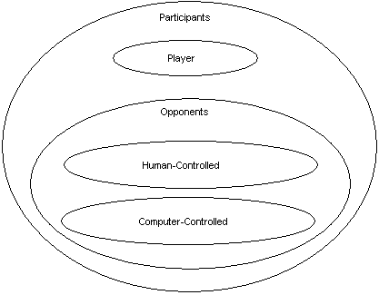

Game Overview
Scavenger Hunt is a competitive game between a group of four to eight participants, where the goal is to be the first to collect a list of scavenger items. The list of scavenger items will be unique for each player and a player must collect all items on his or her list in order to win. Once any player has collected all of the items on his or her list, the game is over. The scavenger items have no use other than to be collected. In order to be considered collected, the scavenger item must be obtained and returned to the drop-box. The drop-box is a repository for scavenger items, and all players use the same one. There is one drop-box per level. Scavenger Hunt also employs a type of memory game in that the player may only see his or her list of scavenger items while at the drop-box.

All of the action takes place in a single outdoor setting, which is called a level, and the action is from a second-person three-dimensional perspective similar to that found in Super Mario 64.

In addition to scavenger items players may also obtain gags, which are special items that can be used to hinder any single opponent. Once a gag is used, it is lost, and cannot be used again. A player may only hold one gag at a time, but over the course of a round may obtain any number of gags. Obtaining a gag when one is held simply replaces the currently held gag with the most recently obtained one.

The players may also choose to activate a special game event known as a Trick-or-Treat. The result of the Trick-or-Treat will either be good for the activating player or bad for all participants.

Scavenger items, gags, and Trick-or-Treats may be found at a number of special locations in each level. These locations are known as stations and there will be at least two stations for each scavenger item category, two stations for gags, and two stations for Trick-or-Treats. The stations’ contents will be identifiable by the color of the station itself. In order to activate a Trick-or-Treat, obtain a scavenger item, or obtain a gag, the player must complete a sequence of button presses at the station. This sequence will be shown on the screen and the player may complete it as fast or as slow as they like. The act of completing a sequence is called searching a station. More than one participant may attempt the sequence for the same station simultaneously. The scavenger item, gag, or Trick-or-Treat is awarded to the participant who completes the sequence first. Once a sequence has been completed at a station, the scavenger item, gag, or Trick-or-Treat is awarded. The station will then immediately be relocated to another hot-spot in the level. Hot-spots serve as spawning points for stations. There will be at least twice as many hot-spots as stations on the level. The presence of a station is the only visual indicator of the location of a hot-spot. Hot-spots can be reused to spawn stations any number of times.

Scavenger items are divided into categories. The category of a scavenger item determines which station it will appear in. The player’s list will contain both the name of the scavenger item and its category color. By searching any station of a needed category, the player is guaranteed to find a scavenger item with the needed name. For example, the player needs the “horseshoe” scavenger item so they search the orange station, which dispenses scavenger items from the “sports” category. If the player searches a station of a category that they do not need they will obtain a random scavenger item from that category. Unneeded scavenger items may be collected, but do not further the player’s goal of completing their list.

As a player obtains scavenger items during a round, the player fills his or her personal inventory, which has limited space. Once the inventory is filled, no additional scavenger items may be obtained until it has been emptied at the drop-box. This is the only way the player can remove items from his or her inventory. The currently held gag is not placed in the player’s inventory and does not use any inventory space.

In addition to the limited inventory space, carrying a large inventory affects how fast the player is able to move about the level. From an inventory space of zero to one-third full, the player moves at full speed. From above one-third to two-thirds full, the player moves with a moderate speed penalty. Above two-thirds full, the player moves with a significant speed penalty.

To temporarily speed up how quickly his or her character moves the player can activate boost, which is a limited resource. If the player continues to boost once the boost is exhausted, the player’s character will become winded, and will be unable to move for some period of time. As time passes, the boost will slowly recover.

A collection of statistics determines a character’s movement speed, boost speed, inventory capacity, gag effective radius, and complexity of search sequences. These statistics form part of a character’s personality, and do not change.

Occassionally, the player may obtain a special gold scavenger item by searching a scavenger item station. If the player successfully collects a gold scavenger item, a permanent record of the achievement is entered into the player’s profile. These gold scavenger items are extremely rare, and it is estimated that only one will be discovered during any round. Collecting a gold scavenger item is otherwise no different than collecting a regular scavenger item.

The player’s profile is a record of the player’s achievements in Scavenger Hunt. The profile is saved after a round is completed, and the contents of a player’s profile determines their rank. A player’s rank is represented by an icon which can be seen by other players during game setup.

The player must decide during game setup whether he or she will join or host a game. Hosting a game means that the player will decide how many opponents and of what type there will be. Joining a game means that the player will utilize an internet or local-area-connection in order to participate in a game where a human-controlled opponent is the host. If a player decides to host a game where all the opponents are computer-controlled, no internet or local-area-connection is required.

Game Flow

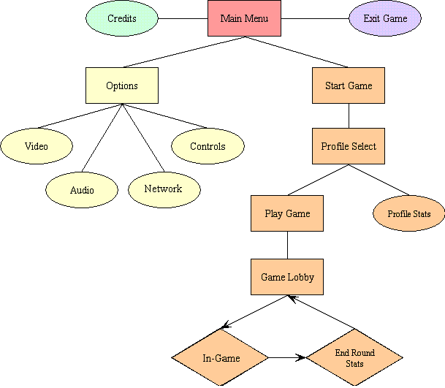
At the start of the game, the player finds the opening splash screen with the DigiPen logo, which fades to the title screen. At this point, the player has the option of viewing the credits for the game, adjusting game settings, quitting the application, and starting the game setup by selecting the appropriate menu option.

Once the player has chosen to start the game, they must select the profile they will use. If the player is playing for the first time, they will be invited to create a new profile. During selection of a profile, the player will be able to view the profile’s statistics.

Once a profile is chosen, the player will proceed to the lobby. Please see the Lobby section for a description of the lobby.

Once a game has started, the player will proceed to a loading screen. The participant who finishes loading first will see a screen that says, “wait for other players.” When all participants have finished loading, a countdown begins and the player’s scavenger item list is displayed. Once the countdown ends, players may begin the hunt. A player may terminate the display of the scavenger list early, but they must still wait for the countdown to end before they can begin moving.

During the game, the player’s primary source of information will be the heads-up-display (see the HUD section for details).

Once a round is over and a winner is determined, the participants will proceed to a display of a summary of the round, including the elapsed time, the number of scavenger items collected by each participant, as well as the final standings. This will be shown in a standard leader-board fashion. Once the player has finished examining the statistics, he or she may proceed back to the game lobby.

Game Screens

Lobby
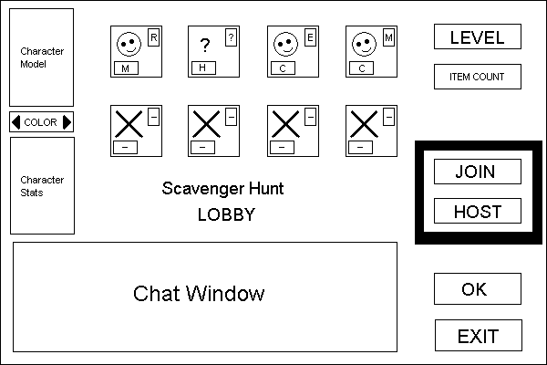

The above is a mock-up (not to scale) of the lobby.

In the lower-right corner of the lobby are two buttons, “OK” and “Exit.” Choosing “OK” will confirm that the player is ready to begin a game and finalize that player’s options. Until all human-controlled participants have chosen “OK” the game will not begin. Choosing “Exit” will return the player to the previous menu, or if the player has already selected “OK,” the player may again return to changing options in the lobby, such as character selection.

In the upper-left corner is a rendering of the player’s currently selected character. This is a non-interactive display. Directly under this is a set of two buttons that allows the player to select the texture that his or her character will use. Directly under this is a non-interactive window displaying the currently selected character’s statistics.

In the top central area of the lobby is a collection of eight windows that show the current participants. Each window shows a character’s face, a big ‘X,’ or a question mark. In the lower-left corner of each window is a button that will show either an ‘M,’ an ‘H,’ a ‘C,’ or a ‘— .’ In the upper-right corner of each window is an icon that displays rank (for human-controlled participants) or button that displays difficulty setting (for computer-controlled participants).

The ranks displayed for human-controlled participants can be one of: ‘R,’ ‘P,’ ‘X,’ or ‘A.’ ‘R’ stands for rookie, ‘P’ for professional, ‘X’ for expert, and ‘A’ for master. The difficulty setting for computer-controlled participants can be one of: ‘E,’ ‘M,’ or ‘H.’ ‘E’ is for easy, ‘M’ is for medium, and ‘H’ is for hard.

‘M’ stands for “me,” and the player will see his or her character’s face here. ‘H’ stands for “human,” and the character face for this human-controlled opponent will be displayed here, or if no human player has joined into that window, a ‘?’ will be displayed. A ‘C’ is shown for all computer-controlled players, and the character face for this computer-controlled opponent will be shown here. An ‘—’ is shown for any window without a participant.

Any player may select the window marked with ‘M’ and choose his or her character from a list.

When the player is hosting, they may select any of the windows in this section and assign either a computer or human controlled player. The hosting player may also choose which character any computer-controlled opponent will use. If the player has more than three opponents, he or she may also choose to close an opponent’s window, in which case the opponent is removed. The hosting player can change the difficulty setting for computer-controlled participants as well.

All participants must use a unique character. Uniqueness is determined by both character and texture. If a player joins a game where his or her character and texture is already in use, the following mechanism will be employed to resolve the conflict: If the conflict is with a computer-controlled opponent, the player keeps his or her selected character and texture, and the computer-controlled opponent is automatically assigned a different texture. If there are no available textures remaining for the computer-controlled opponent’s selected character, then the computer-controlled opponent is assigned a random available character and texture. If the conflict is with a human-controlled opponent, then the player is informed of the conflict with a message: “Your selected character and/or texture has already been chosen by another player. Please select a different character and/or texture from those available.” Until the player chooses a unique character, they will be unable to select “OK.”

In the upper-right portion of the lobby is the level selection button. Directly below this is a button for choosing the number of scavenger items that will appear on each player’s list. If the player is not hosting, these buttons will not be selectable.

In the center of the right side of the lobby is a radio-button group that will allow the player to choose to join or host a game. The default choice is “host.” It will be determined before the lobby is reached whether or not the player’s computer will support a networked game. If the player’s computer cannot support a networked game, then this choice of join or host will not be visible and will be replaced with the message “Network could not be found. You may still host a single-player game.” If the player selects

The lower-left corner of the lobby screen is where the player can type messages to be sent to his or her opponents. A player’s own messages will be displayed as well. Computer-controlled opponents will not send messages here.

Heads-up-Display (HUD)
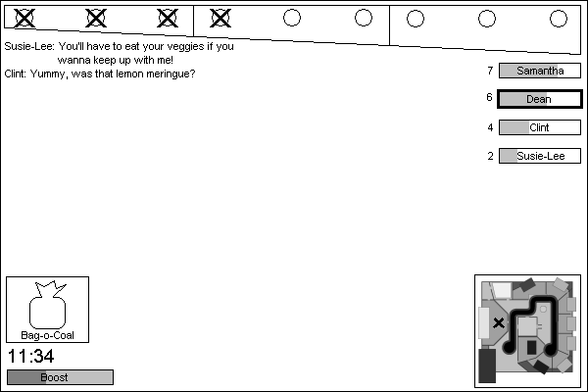

The above is a mock-up (not to scale) of the heads-up-display (HUD).

The topmost box is the player’s inventory. The circles represent inventory slots, and an ‘X’ in an inventory slot means that there is a scavenger item being held in that slot. When the player obtains a scavenger item, it will fill the first available inventory slot from the left. The divisions of the inventory represent the level of speed penalty the player will experience by having a scavenger item in that division. The farthest right represents the highest penalty; the farthest left no penalty.

The series of names along the right of the screen represents the leader board. Participants’ names will be displayed here in descending order, with the participant who has collected the greatest percentage of his or her needed scavenger items listed at the top. The leader board will update the names in real-time as the percentages change. The tiebreakers will be the number of needed scavenger items in the participant’s inventory, and if necessary, the order that the participants joined the game. The player will see his or her name with a bold border. Each participant will have a number to the left of his or her name that indicates the number of needed scavenger items he or she has collected. In addition, the box the name appears in serves as a progress bar. This progress bar will fill from the left, and indicates the percentage of needed scavenger items that the participant has collected.

In the lower-right corner is the mini-map. The player will only be able to see his or her current location, represented as an ‘X.’ There is one case where other things may appear on the mini-map—see “S’mores” in Trick-or-Treat Effects in the Appendix.

In the lower-left of the screen is the player’s boost meter. This meter will decrease as the player uses his or her boost. The meter decreases from right-to-left, and increases from left-to-right.

Directly above the player’s boost meter is the game timer. This timer keeps track of how long the round has lasted so far. It is not a countdown to the end of the round.

Above the timer is an icon showing the player’s held gag. Above this is the in-game chat display.

Level

The level field in Scavenger Hunt will have a bounding barrier that the player cannot pass through. The layout of the level will have a hint of a maze. It will be on the same scale as the characters. Since the characters are children, the buildings and level objects will seem big.

The buildings serve as obstacles, and cannot be entered by the player, with the exception of any open-air structures, such as a gazebo. The level’s drop-box will be centrally located, and will be accessible by multiple routes. This is meant to prevent one participant from “guarding” the drop-box.

In addition to buildings, the level will also contain fences. These fences cannot be passed through: the player must go around. A player can attempt to use a gag against an opponent through a fence, and the fence will not prevent the gag from working. Fences do not have gates or other moving parts.

Trees and shrubbery will serve as additional obstructions for the participant as well as unique level objects such as streetside mailboxes in front of the houses.

Any level object can function as a location of a hot-spot. Potential hot-spot locations will be marked in the level file.

The level will have at least thirty-two hot-spots where a scavenger item, gag, or Trick-or-Treat station can be placed. At the start of the level, sixteen random hot-spot locations will be chosen and a station placed there.

Please see the Maps section for a map of the Scavenger Hunt level.

Character Statistics

- Run Speed – This is the standard movement speed of the character. Those with better running speeds will move faster than other characters.
- Inventory Space – This value determines how many items the character is able to pick up. A character with better inventory space is able to hold more items without being weighted down as quickly.
- Boost – This attribute governs how fast a character runs while boosting.
- Intelligence – This determines how difficult the station sequences are for the character. A character with higher intelligence will have a shorter (and therefore easier) sequence to solve than the average length.
- Gag Effectiveness – This value determines the effectiveness of using a gag against an opponent. Higher gag effectiveness controls how wide a radius a character can be from an opponent and still score a hit with a gag.

Each character will have a grade associated with each attribute. A grade of ‘F’ indicates the lowest value, and a grade of ‘A’ indicates the highest value with all letter grades in-between. Please see the Character Statistics chart in the Appendix for a breakdown of each character’s personal statistics.

Player Actions
Participants in Scavenger Hunt have a common set of actions available to them. Each will be addressed in its own section.

Movement
The player is able to move around in the level with four degrees of freedom. The basic movement commands are move left, right, forward, and backward—all are with respect to the direction the camera is facing. The camera itself can be rotated around the player both clockwise and counter-clockwise.

The player will move at a constant speed with no acceleration. Terrain and hills will also have no effect on the player’s speed. The base speed for the player will be determined by the character he or she has selected. The player’s inventory will also have an effect on how fast he or she moves (see Character Speeds in the Appendix).

The player cannot get tired by moving around the level, although as will be explained below, boosting around a level may cause the player’s character to become winded.

Boosting
While moving, the player may also use boost. As the player uses boost, it will decrease at a fixed rate. Once the boost resource is exhausted, the player’s character will resume moving at its base speed. The effect of continuing to use boost once it has been exhausted is to cause the player to become winded, which temporarily keeps the player from moving.

Whenever the player is not boosting, the boost resource will be recovered at a fixed rate.

The boosting speed of the player’s character is also affected by how full the player’s inventory is (see Character Speeds in the Appendix).

Searching
All stations will have a sequence that must be completed in order to obtain the scavenger item, gag, or Trick-or-Treat. The sequence will consist of a series of directional indicators as well as a button indicator displayed in the order that they need to be pressed from left to right.

The player will use his or her controls to enter the sequence, with the directional indicators corresponding to the movement controls, and the button indicator corresponding to the “accept” button. (Please see the Controls section for an explanation of these controls.)

The directional indicators map to the movement controls in the expected way, with left, right, up, and down corresponding to left, right, forward, and backward, respectively.

If the player fails to enter the sequence correctly, the player will receive a “failed” message and will have to restart the sequence or move to another station. The player may attempt a sequence any number of times until they succeed. Sequences are not timed; the player can take as long as he or she wishes.

A player in the middle of completing a sequence will be interrupted if one of the following happens:
- An opponent at the same station completes the sequence first;
- A Trick-or-Treat is activated that moves the station or the player;
- The player is hit with any gag;
- Any opponent wins the round.

The length of a player’s search sequence depends on his or her intelligence statistic (see the Search Sequence Complexity section in the Appendix).

Inventory Management
The player is largely freed from explicit inventory management. Two of the player’s actions will affect his or her inventory: obtaining a scavenger item, and returning to the drop-box. When the player obtains a scavenger item, it is added to his or her inventory. When the player returns to the drop-box, his or her inventory is emptied. The player has no control over where in his or her inventory an obtained scavenger item is placed. All scavenger items are removed from the player’s inventory upon returning to the drop-box. When a player’s inventory is filled, he or she cannot obtain additional scavenger items (see Inventory Space in the Appendix).

A player’s inventory can also be modified by two gags (see “Snake Can” and “Bag-o-Coal” in Gag Effects in the Appendix) and by two Trick-or-Treats (see “The ‘ol Switcheroo” and “Take Out the Trash” in Trick-or-Treat Effects in the Appendix).

The player’s inventory has an effect on how fast the player can move, both at base speed and while boosting. This penalty is specified in Character Speeds in the Appendix.

Using Gags
Participant interaction in Scavenger Hunt is accomplished through the use of gags. In order for a player to use a gag against an opponent, the player must get the opponent within some small distance (see Gag Effective Radius in the Appendix). Once the opponent is within range, the player can then push the Use Gag button (see Controls for an explanation of the buttons) to attempt to use the gag. If the opponent does not get outside the player’s gag effective radius before the gag-throwing animation is over, the opponent will be hit with the gag and will suffer its ill effects. If the opponent escapes the player’s gag effective radius before the animation completes then there is no effect. Either way, pressing the Use Gag button will consume the gag.

Each participant may only hold one gag maximum. If a participant gets another gag, then the new gag will replace the gag that the participant currently holds.

Please see Gag Effects in the Appendix.

Trick-or-Treats
The player may also activate Trick-or-Treats by searching the appropriate station.

Please see Trick-or-Treat Effects in the Appendix.

Controls
The controls in Scavenger Hunt will be similar to First-Person-Shooter-style controls. There will be four movement keys: move forward, move backward, move left, and move right. For purposes of the sequence puzzles, the move keys cannot be bound to an analog axis. There will also be two rotate keys: rotate left, and rotate right. Note that the move keys are all relative to the current rotation. There will also be three action buttons: search, use gag, and boost. In addition, there will be two navigation buttons: accept and decline (by default, these two buttons are assigned to search and use gag respectively).

Default controls are displayed below:

In-game Menu Access
Game Menu | Escape key
Movement (cannot be bound to an “axis”)
Left | A
Right | D
Forward | W or Up Arrow
Backward | S or Down Arrow
Rotation
Rotate Counter-clockwise | Mouse Left or Left Arrow
Rotate Clockwise | Mouse Right or Right Arrow
Actions
Accept | Left-click or Enter/Return
Decline | Right-click or Backspace
Search | Left-click or Left Shift
Use Gag | Right-click or Left Control
Boost | Spacebar

Winning Conditions
The object of the game is for a player to complete his or her list of scavenger items before his or her opponents do. To increase chances of winning, a player can use gags to hinder opponent’s progress or go to a Trick-or-Treat station to attempt for a treat.

Once a player has obtained his or her final needed scavenger item, all opponents will be notified via game message that Player X has all their items and is about to win. As an added hurdle, all opponents who do not have their last scavenger item in their inventory will receive infinite boost. If one of Player X’s opponents is not able to complete his or her list or stop Player X from getting to the drop-box, then the round ends and Player X is declared the winner.

Also, as a side task, players can keep an eye out during game rounds for special gold scavenger items that are permanently stored in the player’s profile and help to increase the player’s rank.

Artificial Intelligence
Artificial intelligence (AI) will be utilized for all of the computer-controlled participants.

The approach to the AI will be done using a customizable playing profile for each computer-controlled opponent. Each AI personality will be made up of a complex structure that will be designed to help the computer navigate effectively through each level, remember where it saw items of interest, and make on-the-fly decisions such as choosing to keep its distance from its opponents.

Each AI player will be able to navigate about a level by following a series of waypoints placed around the level when they want to cover large distances. The waypoints are set up to provide optimal paths around the level, helping the AI players around all of the obstacles. When an AI player gets close to its intended destination, it will use a wall-tracing algorithm to find a path directly to the desired location.

AI players will interact with the game by way of a “virtual controller.” The virtual controller is simply a mapping of the controls that a human player may use. The AI players will be forced to interact with the game the way a human player would, supplying commands on a controller as opposed to direct actions.

Every action a human player can perform, an AI player will be able to perform also. For each of these actions (searching for a hot-spot, retrieving a scavenger item, gag, or activating a Trick-or-Treat, chasing and pulling a gag on opponents, and running back to the drop box) the AI player will assign a rating depending on how much it wants to perform each action. The rating values are influenced by each AI player’s individual personality, and the action with highest rating at any given time is considered the best course of action.

Each AI player will have a simulated “brain.” This brain consists of a memory, a knowledge base, a logic resolution component, a sensory component, and a reflex component.

Each computer-controlled participant will have simulated memory, and they will forget where they saw things over time. When an AI player fills in information in its memory (the location of a hot-spot, an item on its scavenger list, etc.), the information is given a value that decays as the game plays on. When the value reaches zero, the information is removed from the memory and is “forgotten.” Also, unless they are close to an opponent retrieving a scavenger item they wanted before they go back to get it (thereby “witnessing” the act), the AI player will make the mistake of going back to the station they last saw the scavenger item only to find it gone. So, when a hot-spot is moved, the AI player may not be “aware” of it.

The result of these efforts should be computer-controlled players that behave in a relatively human-like manner. Additional efforts will have to be made, however, so that the AI offers the appropriate challenges of being clever without cheating, and also so that the AI does not make too many mistakes causing a lack of challenge to experienced players. Each AI personality can be tailored by the game to suit the difficulty level selected by the player.

Profiles
Before any player can play the game, they must choose or create a profile. A player’s profile is a permanent record of statistics for the player, number of gold items collected, and the player’s current rank (see Appendix: Profile Statistics). Between games, a player may browse through his or her profile information at leisure.

Each player’s rank will also be visible to other players in the game lobby before a round starts. This allows players to have bragging rights as well as to let other players know how experienced their opponents are.

Descriptions

Characters
Scavenger Hunt will feature four unique characters that a player can select for each round. The potential characters are displayed below:

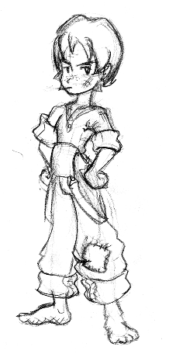 | Samantha  Twelve years of age, Samantha (or Sam as she likes to be called) is the tomboy of her neighborhood. She loves spending her days roaming about outside climbing trees, jumping off the bridge over the lake, and collecting various slimy bugs.  Sam is attracted to this scavenger hunt because she enjoys any opportunity to give the boys a hard time and she has no fear of any other girl that she knows.  Samantha is more focused on out-doing the boys than anything else, but she favors a well-rounded approach. She has average abilities in all categories. | 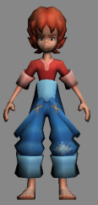
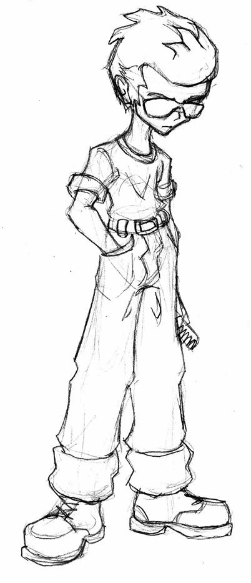 | Dean  Only ten, Dean idolizes his greaser older brother. He idolizes him so much that he has taken to emulating every bit of his older brother’s appearance. Dean doesn’t need a sunny day as reason to wear his ever-present sunglasses.  Dean is a quick-witted and inventive boy who holds back his great enthusiasm for the scavenger hunt behind his carefully crafted “cool” manner. Although he does his best to downplay his intelligence, he is near the top of his class in grade school.  Dean is as gifted at pulling pranks as he is at schoolwork. His pockets are pretty small and he can’t carry much at all. He refuses to carry a backpack, because it would “ruin his image.”  Although Dean can run long distances with ease, he holds back when sprinting for fear of messing up his hair. | 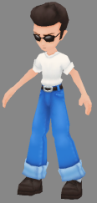
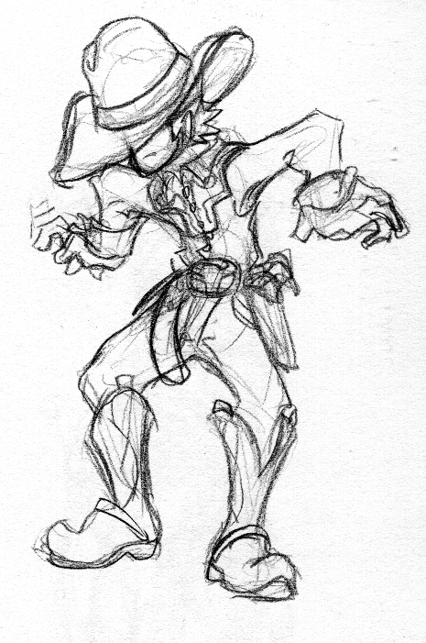 | Clint  At fourteen, Clint is the old man of the bunch. He wears the classic cowboy getup, complete with wide-brimmed hat, cowboy boots and gun holster. His mom took his cap gun away because he kept scaring the family cat with it.  Clint may not have developed his lightning-fast draw yet, but he is skilled at pulling a fast one on his impressionable young friends. His deadpan delivery makes him a natural comedian; consequently, he rarely misses when it comes to using a gag.  His cowboy swagger doesn’t win him any races, though he makes up for it a bit when running for the hills. Like any good cowboy, he has plenty of room for stowing his gear, or in this game, scavenger items. | 
 | Jennie  At nine years old, Jennie is the youngest of the participants. Jennie is a straight-A student who loves school and succeeding in everything else that she does. Jennie joins the scavenger hunt after returning early from school, disappointed to find it has been cancelled for the day.  Jennie is blessed with remarkable intelligence for someone her age, and has an equally amazing ability to run short distances very quickly. Her weakness is that she has extremely limited capacity for carrying things, in part due to her diminutive size and in part due to her lack of pockets. | 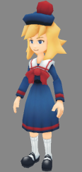

Map

Suburbia
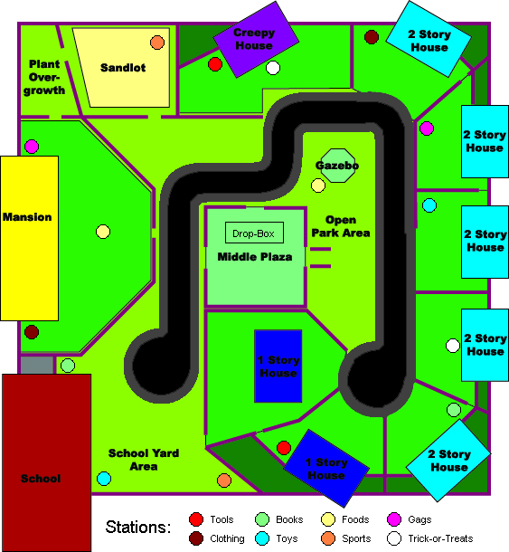

The above is the map for the suburban level from an overhead view. The black area with a dark grey border represents a street, while the green areas represent grassy yards. The violet lines represent fences.
Music
The musical style for Scavenger Hunt will be a mixture of 1950s rock-a-billy and doo-wop with contemporary musical styles, approaches, and mixing techniques. The music will sound like it’s rooted in the 50s to sound appropriate. However, so as not to lose young players who may not enjoy straight nostalgia, the musical track selections will be mixed and recorded to a modern dance or house party beat. The result should be a fun eclectic mix of old and new musical styles that will appeal to a broad audience.

Sound Effects
Scavenger Hunt will contain a varied collection of sounds ranging from atmospheric noises like chirping birds and snapping twigs to splat noises for when a pie is thrown at someone to gentle jingles for when a player collects useful items to clicks and chimes for the opening menus.

Sound effects will be used throughout the game to spice up the presentation. Also, sound will be used to help indicate to players on a more subconscious level when they are standing within a searchable area or about to be gagged. The idea is to make the actions and interfaces in the game “feel” more intuitive and transition more smoothly by using sound in a supportive yet discreet manner to complement the visuals.

Items
There are six categories of scavenger items, with five scavenger items per category. The following is a complete list of all scavenger items, by category, along with the category’s color. The station that dispenses scavenger items from a particular category will appear in the category’s color.

Tools—Red | Books—Green | Foods—Yellow
Sledge Hammer | Funny Papers | Malt Shake
Monkey Wrench | Comic Book | Grilled Cheese
Bicycle Pump | Dictionary | Pumpkin Pie
Watering Can | Coloring Book | Hot Dog
Paint Brush | Crossword | Turkey Leg
Clothing—Maroon | Toys—Blue | Sports—Orange
Turtleneck | Pogo Stick | Catcher’s Mitt
Mittens | Jack-in-the-Box | Horseshoe
Polka-dot Necktie | Toy Soldier | Ref’s Whistle
Bunny Slippers | Frisbee | Hockey Puck
Top Hat | Teddy Bear | Bowling Pin

In addition to the scavenger items, there are five gag items, five Tricks, and five Treats available from their specific stations.

Gags—Purple | Tricks—White | Treats—White
Whipper-snapper | Shuffle the Deck | Cookie
Cream Pie | The ol’ Switcheroo | Lemon Drop
Whoopee Cushion | Total Eclipse of the Sun | S’mores
Bag-o-coal | Change Places! | Peppermint
Snake Can | Take Out the Trash | Jelly Bean

Level
There will be one level produced for Scavenger Hunt. The level is described as follows:

Suburbs
American suburbia at its 1950s best. The streets have again been made clear for the safety of the children as they rush about looking for their scavenger items. Run from yard to yard around whitewashed picket fences, clotheslines, gardens, and picnic tables. Step around storm cellar doors and patio furniture as you hunt down the items on your list.
Be mindful, the fences, bushes, and trees make for plenty of ambush spots for potential gags. Also, there are lots of houses, so trick-or-treats will be fairly easy to come by, for better or for worse.

Appendices

Database

Character Statistics
Character | Run Speed | Inventory Space | Boost | Intelligence | Gag  Effectiveness
Samantha | C | C | C | C | C
Dean | B+ | D | F | B | B-
Clint | F- | B+ | B- | F | A+
Jennie | D | F | A+ | A | F

A letter grade converts to a number by using the table below.
Letter grade | Number
A+ | 100
A | 90
B | 80
C | 70
D | 60
F | 50
F- | 40

A plus sign (‘+’) on a letter grade other than ‘A’ adds five, whereas a minus sign (‘-’) on a letter grade other than ‘F’ subtracts five.

Character Speeds
All of the speeds listed are in meters per second (m/s).
Character | Normal | Boosted | Weighted | Weighted Boosted | Heavily Weighted | Heavily Weighted Boosted
Samantha | 3.0 | 5.0 | 2.3 | 3.8 | 1.5 | 2.5
Dean | 3.3 | 4.1 | 2.5 | 3.1 | 1.7 | 2.0
Clint | 2.0 | 4.9 | 1.5 | 3.6 | 1.0 | 2.4
Jennie | 2.9 | 6.6 | 2.2 | 4.9 | 1.5 | 3.3

The formula used for determining these speeds is shown in the following table.
Speed | Equation
Normal | ((0.8*(Run Speed)+0.2*(Boost))/70)*3.0
Boosted | ((0.8*(Boost)+0.2*(Run Speed))/70)*5.0
Weighted | 0.75*(Normal)
Weighted Boosted | 0.75*(Boosted)
Heavily Weighted | 0.5*(Normal)
Heavily Weighted Boosted | 0.5*(Boosted)

Inventory Space
Character | Max Number of Scavenger Items in Inventory
Samatha | 9
Dean | 6
Clint | 12
Jennie | 3

Search Sequence Complexity
Character | Length of Search Sequence
Samatha | 7
Dean | 6
Clint | 9
Jennie | 5

Gag Effective Radius
Character | Distance (in meters)
Samatha | 2
Dean | 2.2
Clint | 3
Jennie | 1

Gag Effects
Gag Name | Effect
Whipper-snapper | Randomly rotates and/or flips opponent’s directional controls for thirty seconds.
Cream Pie | Obscures opponent’s vision for thirty seconds.
Whoopee Cushion | Creates a fake station, wastes player’s time in searching.
Bag-o-coal | Junk scavenger item, fills opponent’s inventory.
Snake Can | Opponent loses entire inventory.

Trick-or-Treat Effects
Tricks
Shuffle the Deck | All stations will be removed from the map and will relocated to a different available hot-spot.
The Ol’ Switcheroo | All participants will randomly switch inventories with a different participant.
Total Eclipse of the Sun | All stations appear colored gray and thus indistinguishable.
Change Places! | All participants will randomly switch positions with a different participant.
Take Out the Trash | Every participant receives a full inventory of unneeded scavenger items.
Treats
Cookie | Rewards unlimited boost for thirty seconds for the activating player.
Lemon Drop | Removes bad effects of gags or Trick-or-Treats and grants immunity from same for thirty seconds for the activating player.
S’mores | Causes station and opponent locations to appear on the activating player’s mini-map for thirty seconds.
Peppermints | Allows the activating player to instantly obtain scavenger items, gags, or Trick-or-Treats without completing a sequence.
Jelly Beans | Increase the activating player’s lowest character statistic for the remainder of the round.

Profile Statistics
Each player will have a profile with records specific to them. Following is a list of all statistics that will be recorded and available for every profile:

- Total rounds played
- Total rounds won (also displayed percentage won)
- Total rounds lost (also displayed percentage lost)
- Rounds won / lost on a per level basis
- Rounds won / lost on a per character basis
- Total scavenger items obtained
- Total scavenger items collected
- Total gags pulled
- Total successful gags
- Total times gagged
- Total play time
- Play time on a per character basis
- Play time on a per level basis
- Total gold scavenger items collected

In addition to simply storing a player’s statistics, certain statistics will be used to determine a player’s rank. The statistics that will increase a player’s rank are:

- Total games won
- Total gold scavenger items collected

As more games are won and more gold items collected, the player’s profile rank will increase. In game lobbies, players will be able to view all human-controlled opponents ranks (see Lobby above, for more details).

Porting the Game
Scavenger Hunt will be written in the C++ language according to the ISO standard. Game scripting will be written in standard Lua code. Both of these languages are easily used across several platforms, certainly including those that are capable of running the game in the first place. These platforms include the major PC operating systems- Linux, MacOSX, and Windows.

Scavenger Hunt will also make use of cross-platform libraries for sound, video, input, and so forth. Each of these libraries is available on at least the three above platforms and possibly more. We do not plan on supporting platforms other than those three, but each of the libraries are available in source code form and are licensed to allow the right to redistribute modified versions of them, so they could be ported by the team to platforms aside from the three listed above.

Team Signoff

Jemal Armstrong __________________________
(Art Director)

Jonathan Bryant __________________________
(Producer)

Jackson Dunstan __________________________
(Lead Programmer)

Douglas DaSilva __________________________
(Technical Director)

Shane McIntire __________________________
(Artist)

Kevin Neece __________________________
(Designer)

Eric Smith __________________________
(Product Manager)

