Circular Logic

Technical Design Document

Circular LoGIC

Technical Director
Eric Anderson
Executive Producer
Tristan Hall
Product Manager
Patrick Coughlin
Art & Sound
Jason Bolton
Designer
Justin Kinchen

Table of Contents

Overview 5
Summary 5
System Requirements 5
Roles 5
Development tools 6

Engine Breakdown 7
Graphics 7
Artificial Intelligence 7
Game Play 7
Physics 7
Networking 8
File Formats 8

Code Structure 9
Program 9
Sound, Input 12
Console 14
Resource Bank 16
Application 18
Application States 20
Presentation 22
Bontãgo 24
Networking 26
Physics 28
Artificial Intelligence 30

Milestones 32
Pre Engine Proof 32
Engine Proof 33
Pre First Deliverable 34
First Deliverable 35
Alpha 36
Beta 37
Final 38

Signoff 39

Overview

Summary
Bontãgo will be developed strictly in the C++ language, and will be targeted specifically for the Win32 platform.

System Requirements
- Pentium III 450 MHz or better processor.
- Win2000 / XP.
- 3D video card compatible with DirectX 9.0 with at least 16MB video memory.
- 64MB RAM.
- 50MB Hard drive space.
- Internet / LAN connection for multiplayer.
- . NET framework needed for multiplayer
- DirectSound compatible audio card.

Roles
- Graphics – Eric Anderson
- Networking – Jason Bolton
- Artificial Intelligence – Tristan Hall
- Gameplay / Audio – Justin Kinchen
- Physics – Patrick Coughlin

Overview

Development Tools
- Microsoft Visual Studio 6
- 3DStudio Max
- Direct X 9 SDK
- .NET framework SDK

Engine Breakdown

Graphics
The graphics will be done in 3D using DirectX 9.0. Graphics portion of the game is outlined as ResourceBank, Application and Presentation packages (see Structure).

Artificial Intelligence
The AI will be controlled by a set of fuzzy logic, rules and tables. There will be numerous different strategies and rule tables for the AI to choose between. This is to insure that the player receives a non-repetitive, dynamic opponent to fight off. The AI is in one package (see Structure).

Game Play
Game Play programming will make the game design document a reality. Its only responsibility is defining the game rules. Gameplay’s only dependency is physics. It has no knowledge of video, sound, networking, AI. By decoupling the gameplay like so, will reduce complexity, increase productivity, and enhance modifiability. Gameplay is the Bontago package (see Structure).

Physics
Physics will be designed as an efficient, robust rigid-body simulator so that objects in the game world react, as the player would expect them to. Physics will be the greatest challenge technically in the game, and will need numerous hours of tweaking till it becomes just right. Physics is also contained in a package unto itself (see Structure).

Networking
The first choice networking API will be .NET Remoting. Remoting is a TCP/IP distributed computing framework, included in the .NET framework, downloadable from windows update. Remoting is to WinSock what C is to assembly. Ten lines of Winsock code reduce to zero lines of Remoting code, allowing the developer to solve the same conceptual problems more efficiently.
Second API of choice is ACE, the Adaptive Communication Environment. ACE is a freely available, open-source object-oriented framework that implements many core networking patterns. ACE is targeted for developers of high-performance and real-time applications. ACE is much harder to use then Winsock, but it allows for higher quality network code. Unfortunately, ACE does not possess the godlike elegance of remoting.
Third API of choice is to use the Winsock wrapper Jason previously made in CS260. The wrapper uses many of the same network patterns ACE implements, but it would need a lot more work in order to be suitable for a game project. The wrapper would basically end up being very similar to ACE, however we would rather not reinvent the wheel.
Networking will be handled in the networking package (see Structure).

File Formats
- *.tga will be the selected graphics file format. *.tga offers good video compression with solid 32bit color capabilities.
- *.mp3 will be used for the music and audio file format. *.mp3 has excellent audio compression and also very good sound quality.
- *.x files are used for the models. These files can easily be created from 3dstudio max, and are loadable by DirectX 9.0.
- *.cfg file will be used to store miscellaneous user data, such as control schemes.
- *.config files are used to for the .NET networking system.

Structure - Program

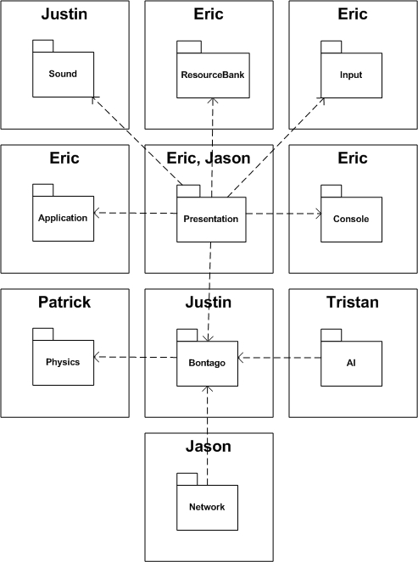

Structure - Program

Bontãgo is subdivided into different packages. Each package will then interact with other packages in order to form the complete game. There are ten packages in all that are fully detailed on their corresponding pages.
Sound - Justin
Sound is a simple DirectShow wrapper class that will handle the initialization, destruction, and playing of any audio.
Application / Video - Eric
This is the main graphical package that handles all the rendering of the game as well as the general application procedures such as creating a window, changing the video device, and resolution changes.
Input - Eric
Input is a wrapper for DirectInput. It controls the DirectInput devices, and polls the devices for input when requested by the presentation package.
Console - Eric
The console is an in-game debugging tool being developed so that we will not need to recompile to change simple variables or change small portions of the code.
Resource Bank - Eric
The resource bank holds all the media data of the game. All the textures, models, and sound files are held within the resource bank and then requested by an interface class to access them. Resources are loaded once at startup.
Presentation – Eric, Jason
Presentation is the hub for the output packages of the game, as well as the state manager of the game. It handles presenting the game to the user through use of the other packages such as video.
Bontãgo - Justin
The Bontãgo package is the biggest state in the game. It handles player updates, AI updates, user interface, and the like, everything you’d see while playing a game. It is also the secondary hub to which networked players, AI, and the local player interact with the game world.
Physics - Patrick
Physics is the Rigid-Body simulator that handles the game world’s physics. Each frame the physics is given the current game world state and it then decides what happens to each block, and resolves each players moves.
AI - Tristan
AI is a player controller, which interfaces with the base player class to handle making its own decisions. It uses fuzzy sets to determine which move to make.
Networking - Jason
Networking is what provides for play over a network.

Structure – Sound, Input

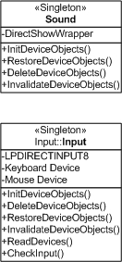

Structure – Sound, Input

Sound
Sound will be controlled by a singleton class that will handle creation of DirectShow devices upon startup, and the destruction of those same devices upon application exit. It will control global sound parameters such as volume as well.
Input
Input will also be controlled by its own singleton class that will wrap DirectInput. It will initialize the devices at startup and destroy the devices upon exit. It will also handle polling the devices for input and requests by the game for input checking. The input class will have two DirectInput devices, one for the keyboard and one for the mouse.

Structure – Console

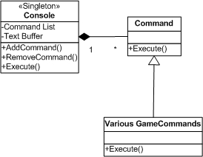

Structure – Console

The console, like sound and input classes, will also be a singleton, so that it may be accessed anywhere in the program. This will allow that anywhere in the game debug information may be spewed out to the console for in-game testing purposes.
The console will have a large text buffer, to hold the information that is printed out to it. Since anything will be able to write information to the console, it will be an invaluable debugging and testing tool. For example, the AI may show to the console what it is doing at the moment. Since it shows this data in game without the compiler debugger, it is much easier to test.
The game console will also have a list of custom commands attached to it. These are created by anyone who wants to invoke a command via a keyword typed in the console. The possibilities of commands are endless, but will mostly deal with changing game states, changing variables, or altering game physics.

Structure – Resource Bank

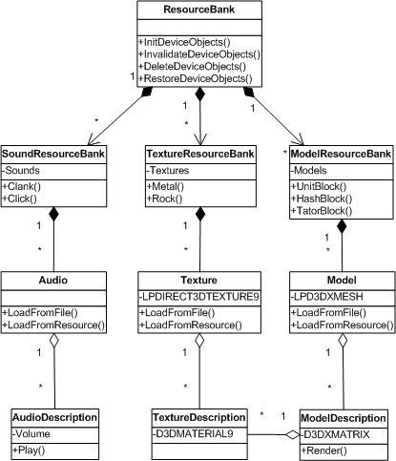

Structure – Resource Bank

The resource bank houses the games assets. It is divided into threes separate banks, one for Audio, Textures, and Models. Each of these banks holds its respective data type. All the games resources are loaded once when the game starts. Because of this, loading will be a one-time occurrence, which for many players will make them very happy.
Each sub-bank has one method for each different type of asset they have. For example, the ModelBank may have a method, UnitCube(), which gives out a pointer to the unit cube model to whatever asks for it. This way the data is separated from the classes that use them, so that if for some reason there is an error, the game will not crash but simply be referencing an invalid pointer, which the ResourceBank can easily deal with.
The ResourceBank will hold an estimated 32MB max data. Most of this data will be held on the video card, if sufficient enough memory exists. If there is not enough video ram, system ram will be used instead.

Structure – Application

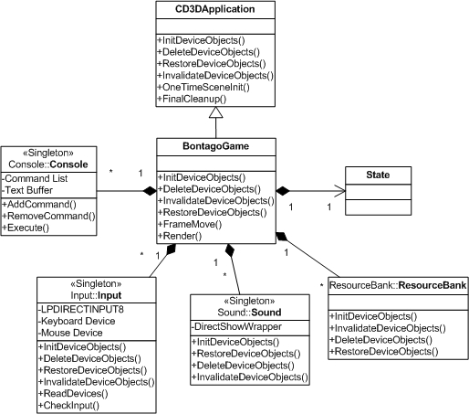

Structure – Application

The application will derive off the DirectX 9.0 framework provided by Microsoft. The framework allows for quick set up of a Direct3D application and provides window management as well as rendering and basic frame update procedures. Because of this, the BontagoGame class will also serve as the graphics portion of the game, and will handle rendering of the current application state.
BontagoGame also contains the singleton classes described earlier. It notifies these classes when the application begins so that they may initialize and also notifies them when the application exits, so that they may be destroyed properly.
BontagoGame also contains the current state of the game. Each frame the state is updated with the time delta and then is rendered by the presentation package, which could also somewhat be considered as the application class.

Structure – Application States

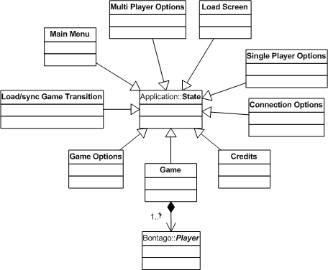

Structure – Application States

Bontãgo will follow the basic finite state machine model when handling which state the game is currently running. It will only run in one state at a time, and the application class will handle that state.
Each state will derive off the base state. The derived classes may contain a variety of different things needed for its individual state, such as menu buttons and whatnot, which it will have the presentation package present.
For example, the Bontãgo state is basically playing in the game. As part of the states class, it would contain all the necessary information needed to run the game, such as the player list, the game world, and so on. Each frame it would get updated and rendered one time. If the state of the game changes, the application is told this and calmly changes from one state to the other.
Load Screen
Your basic game-loading screen.
Single Player Options
Displays options for playing a single player game.
Connection Options
Displays networking options, for playing a networked game.
Credits
Shows important peoples names.
Game
When you are playing a game.
Game Options
Shows general game and application related options available for the game.
Load / Sync Transition
Used when starting a multiplayer game to ensure all clients stay in sync.
Main Menu
Shows the main menu of the game.

Structure – Presentation

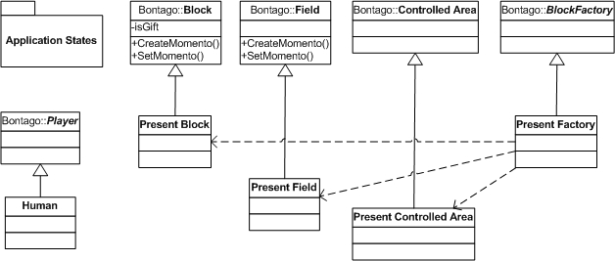

Structure - Presentation

The presentation package will consist of a series of classes that inherit off of what needs to be displayed. This is to allow for access to each objects parameters and necessary display portions. Each game state will have different presentation needs as well, and this package will handle it.
For example, Human derives from the basic Bontãgo game player class. Human’s goal is to draw the user interface, as well as the current block the player is placing to the screen. Also, it needs to handle user input, so it does so here through the use of presentations Input handler class. Sounds are played for example when a user drops a block, so Human handles that as well.
The game world also must be presented, thus the PresentField class derives from the Bontãgo field class, so that it knows what to draw and where to draw it. Blocks in the game world are rendered in a similar fashion to this, by using a PresentBlock class. These various game-world related presentation classes are contained within a holder class, PresentFactory, which merely implements the block factory and instantiates presentation’s sub-classes.
Presentation will use the bulk of the graphics engine and in essence “be” the graphics engine. The graphics engine will support textures (via the TextureDescription class), and 3D models (via the ModelDescription class). Theses are the two major portions of the graphics engine and will be very easy to implement. All effects will simply be fancy manipulations of these two things.
The graphics engine will also support a variety of special effects. Bontago will have real-time shadows (via shadow volumes or shadow mapping) to create realistic lighting effects. Reflections will also be used to add a little bit of “visual pleasure” to the game disc. Basic effect will also be used such as alpha blending and vertex shading.

Structure – Bontãgo

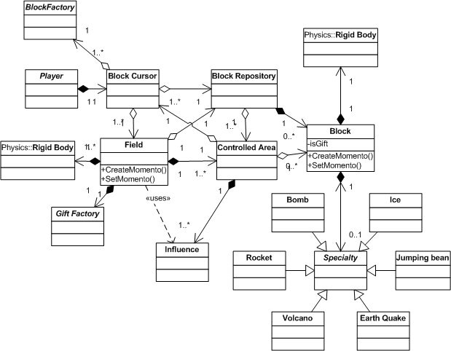

Structure - Bontãgo

Bontãgo is without a doubt the largest state in the game, as it is practically, ‘the game.’ It will contain a variety of different classes, to handle each portion of the game lightly and politely.
It starts with the base block class. This is what most objects will be, a block in the game world. Blocks contain a Rigid Body class, defined by the physics, which handles various physics calculations done each frame. Also, there are special block classes, which inherit off the basic block class, one for each type of special block. These classes deal with the specific parameters associated with each special block. For example, the bomb block controls how powerful the explosion is when it is activated.
Special Blocks are special case block in the game-world. Each different special block has its own class that implement the special functionality of each block. These functions will mostly modify the surround geometry and rigid bodies. For example the ice block when activated will modify the coefficient of friction on the surrounding blocks and portion of the game board.
All these blocks in the game world are held within a BlockRepository. The BlockRepository maintains a list of each block in the world, and deals with when new blocks are added or when blocks fall off the game world and disappear.
The ControlledArea class and the Influence class use the BlockRepository to determine player influences. ControlledArea determines the influence of a given player, and then Influence handles this by allowing / disallowing the player to place a block at a given location.
The GameField class is the ‘game world’ referred to above. It is the disc that the players play on. It contains the various other classes such as BlockRepository. GameField is also another class that contains a Rigid Body, to handle the tilting and collision of the board.
The GiftFactory and BlockFactory are like a store where items come from. BlockFactory is in charge of divvying out blocks to players each turn. GiftFactory is in charge of creating block specialties.
BlockCursor is the class in charge of placing the current block into the game world for the player.

Structure - Networking

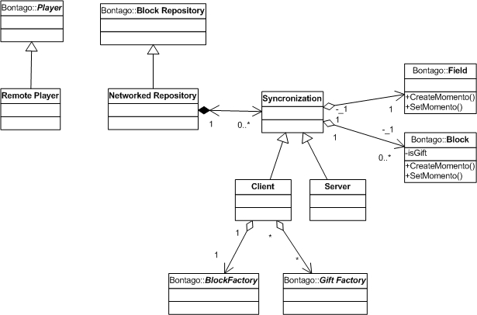

Structure - Networking

The network repository inherits from repository to intercept events and send them to the server. The remote player represents a player on remote computer. The client synchronizer will get block creation events and use the factories to make them on the local computer. The server will forward events to all clients. If remoting is used, the above classes will delegate to a .DLL that contains the remotable objects. If not, the above classes will do the networking.
Networking will handle player dropping by allowing the server to choose to either wait for that player to return (reconnect) or replace him with an AI controlled player. If the dropped player is replaced with an AI then that player may rejoin the game and take back his position in the game.
Players will be locked once the game starts. This means that new players may not join a game in progress; however, dropped players may rejoin the game they were dropped from (assuming the game is still active).
The largest amount of information that will be sent is the state of the rigid bodies in the game world. These rigid bodies will be sent across during each synchronization of the game. Synchronization will occur when the network is idle.
If remoting is used:
Packets- will be the parameters of the remote methods.
Packet structs- will be unnecessary because remoting marshals and demarshals the method parameters.
Server responsibilities- include forwarding network messages to all players.
Clients architecture- will send and recive messages from the server.
Dropped or missing packets- non existent because we are using reliable tcp.
World sync- will be done when the network is idle.

Structure - Physics

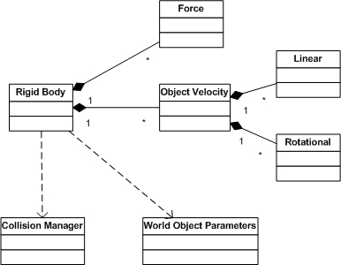

Structure - Physics

Bontãgo physics will employ a Rigid Body simulator. A rigid body class will be developed that will contain all relevant physics objects, such as velocity, mass, acceleration, etc. Each frame, the game world will update the objects then let physics have its way with them. The engine will then apply realistic physics calculations to produce believable physics.
The physics will also use a robust collision manager to determine collisions in a fast efficient manner. A good algorithm must be developed so that many rigid bodies may be present with little slowdown. Physics will definitely be the grand challenge of Bontãgo.
Objects in the game will behave much like real blocks in the real world. If the center of gravity for a tower is tilted over an area where there is no support the tower will fall over. When blocks are placed on corners or edges they will roll off and fall. The only thing that will not be modeled in a Rigid Body physics engine will be “squishing” effects, i.e. the dimensions of the blocks will never change.
Physics will provide for
  - Object Mass
  - Velocity (Linear & Rotational)
  - Forces (Friction, Gravity)
  - Moment (Moments of Enertia)
  - Collisions and Resolutions

Structure - AI

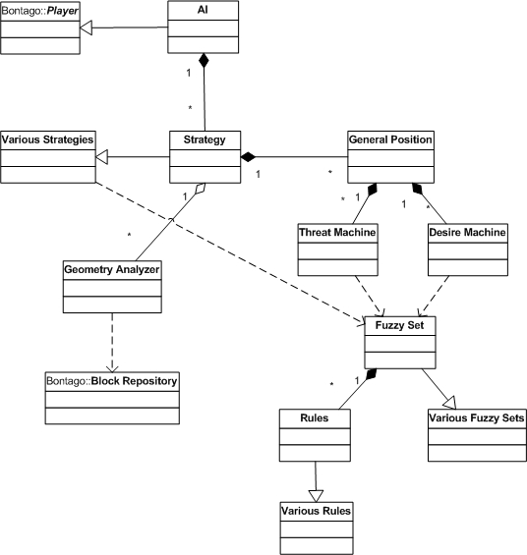

Structure - AI

The AI system will be completely unknown to all other systems. Bontãgo will access the AI’s functionality by creating an AI controlled player and then on every turn it will ask the AI where it would like to place its block. This simple goal will have an extremely complex approach; due to the inherent complexity of Bontãgo.
The first task given to the AI system will be to update its threat and desire machines. Each one of these machines will contain threat or desire classes that when updated will each return a FuzzyGeneralPosition. A FuzzyGeneralPosition is the location of where that threat or desire would like to place the block, and a FuzzyGeneralPosition also contains a floating point value that gives a “how much” to that particular threat or desire. The threats and desires will work with what it knows of the game board, for instance the AI player will know where all of the other players’ influence lies and can therefore calculate which player is the greatest threat at winning.
Then the strategy portion of the AI will takes over. Strategy uses all the FuzzyGeneralPosition that the desire and threat machines output, and puts all of their “how much”’s in a table so it can look up what strategy it will use. A given strategy table might look something like this:
Strategies | Player Threat | Tower Threat | Close to Win | Kill Player
Block Rush | Val < 0.5 | Val < 0.5 | Val < 0.5 | Val < 0.5
Attack Player X | Val > 0.6 | Val < 0.5 | .75 >Val > 0.5 | Val > 0.6
The values inside the chart correspond to how much of an issue that threat or desire is.
After a given strategy has been decided we will use the Geometry Analyzer to pinpoint an exact location. The Geometry Analyzer will use the Block Repository to examine the surrounding area. We will “look” for a sound location to put the block. Then this final location will be return to Bontãgo to be the location that the block will be dropped from. If the we cannot find an appropriate location for our block in the area that we wanted to drop it in (either it would destabilize our tower or just not be good), Strategy can then look at some of the other “high” desires and threats and modify the location and try to examine again, though if this fails more than once we will just have the AI “go with it” to save precious clock cycles.
The different AI levels, easy, medium, hard, will be accomplished by having different rule sets for each type. There can also be personalities to an AI, we can have and AI react more strongly to aggressive playing and then make its only goal to make you lose. The plan is for us to have many personalities for each AI level (easy medium and hard) to make Bontãgo’s AI a dynamic experience every time you play.

Milestone – Pre engine

  - Full application functionality
Resolution changes, device changes, fullscreen / windowed mode
  - Models, Textures
Visible textured models, shadows, environment mapping
  - Basic UI
HUD visible working, block placement into world via mouse
  - Collision Detection
Accurate Block – Block collision tests
  - Joining / Hosting games, Chat
In game chat available, ability to host and join games
  - Basic game layout
Game world visible, play field and blocks on field visible, somewhat interactive.

Milestone – Engine proof

  - Graphic Effects
Shadow Volumes, Environment Mapping, Bump Mapping all visible.
  - Basic working game play
Able to place blocks into the world, as well as see the world be updated with the blocks.
  - Networked game
Ability to join / host a game, and remain in sync with the host.
  - AI playing the game
AI will place blocks in a pseudo-smart manner, implementing a basic fuzzy system.
  - Rigid Body Physics
Blocks will react to given forces, such as gravity and friction, when colliding with other blocks.

Milestone – Pre First Deliverable

  - Game Play
Game will be somewhat playable, not necessarily from start to finish, but user controls will all be working correctly.
  - Networked game
Ability to join / host a game, and see other players updated movements.
  - AI playing the game
AI will place blocks in a smart manner, attempting to play out a strategy.
  - Rigid Body Physics
Blocks will collide realistically, but may have little optimization so the physics may run slowly.

Milestone – First Deliverable

  - Game Play
Game will be fully playable from start to finish with any number of players. Menus will be used via the console / or a very cheap looking screen display.
  - Networking
Game will handle up to 32 players in a network game.
  - AI
Single player mode will be playable against a single AI opponent type, complete from start to finish.
  - Physics
Solid Rigid-Body simulation of the game blocks in the world.

Milestone – Alpha

  - Graphics
All game graphics will be visible within the game; the visual menus will finally emerge, as will the other visual menus.
  - Networking
Game will have little network errors but may have slight issues with performance over slower networks however.
  - AI
Many different AI types will be available, each employing different strategies against the player.
  - Physics
Solid Rigid-Body simulation will be completely realistic. Collision will be solid and near perfect.
  - Game
Game will be fun to play, slight balancing issues may exist.

Milestone – Beta

  - Graphics
Smooth transitions from each menu of the game to the other, crisp nice looking pictures in game.
  - Networking
Few network problems if any will exist, setting up and playing a game over a network will be quick and painless.
  - AI
AI will be able to defeat the player, and adjust to various tactics if it determines one is not working.
  - Physics
Physics will need little tweaking before it nears absolute perfection. Objects will react correctly and will be optimized.
  - Game
Game will be a blast to play, very minor balance issues may exist.

Milestone – Final

  - Graphics
Graphics are gorgeous, wondrous lighting effects, beautiful shadows, jaw-dropping environment mapping effects, incredibly beautiful menu design.
  - Networking
Game will never have any issues when playing over a network. The networking will deal with every technical problem and handle it beautifully.
  - AI
AI will be able to defeat the player, and will be a definite challenge even for master players.
  - Physics
Physics will be fast, efficient, and correct.
  - Game
Game will still want to be played, be terribly addicting, and incredibly fun.

Sign Off

Eric Anderson – Technical Director

Jason Bolton – Art & Sound Director

Patrick Coughlin – Product Manager

Tristan Hall – Producer

Justin Kinchen – Designer

